RAM-IT: ITRO’s ChatBot & Ticketing System

Project Documentation Submitted to the Faculty of the

School of Computing and Information Technologies

Asia Pacific College

In Partial Fulfillment of the Requirements for

Applied Project for IT-MI

MCSPROJ

By

Jayson Quiño Aloya

John Christopher Tee Langcauon

Jan Gabriel Balcueva Prion

Marc Julian De Leon Sajul

Marc Espina Zamora

ASIA PACIFIC COLLEGE

Approval Sheet

RAM-IT: ITRO’s ChatBot & Ticketing System Website

Prepared and Submitted by

*Jayson Quiño Aloya*

*John Christopher Tee Langcauon*

*Jan Gabriel Balcueva Prion*

*Marc Julian De Leon Sajul*

*Marc Espina Zamora*

In Partial Fulfillment of the Requirements for the Degree of

Bachelor of Science in Information Technology

Examined and Recommended for Acceptance and Approval for

Research/Capstone Presentation

___________________________

Ms. Jo Anne M. de la Cuesta, Adviser

Panelists

|  |  |
| --- | --- |
| ___________________________ | ___________________________ |
| Doc. Manuel L. Calimlim, Jr., Panel Member | Ms. Rhea-Luz R. Valbuena, Panel Member |

Acceptance and Approved in Partial Fulfillment of the Requirements for the Degree of

Bachelor of Science in Information Technology

___________________________

Rhea-Luz R. Valbuena

Executive Director

School of Computing and Information Technologies

Table of Contents

Executive Summary 1

List of Figures 2

List of Tables 4

I. Introduction 5

1.1 Project Context 5

1.2 Statement of the Problem 5

1.3 Objectives 6

1.4 Significance of the Project 6

1.5 Scope and Limitations 6

II. Review of Related Literature / Systems 7

III. Technical Background 10

3.1 Current System 10

3.2 Proposed System 13

IV. Methodology 16

4.1 Requirements Analysis 17

4.1.1 User Stories with Acceptance Criteria 17

4.1.2 Product Backlog 20

4.1.3 Event Table 22

4.1.4 Use Case Diagram 23

4.1.5 Use Case Full Description 24

4.2 Gap Analysis 33

4.3 System Analysis and Design 39

4.3.1 Context Diagram 39

4.3.2 Data Flow Diagrams 40

4.3.3 Entity-Relationship Diagrams 45

4.3.4 Activity Diagrams 46

4.3.5 Object Diagrams 49

4.3.6 Class Diagrams 50

4.3.7 Sequence Diagrams 51

4.3.8 Package Diagram 52

4.3.9 Component Diagram 53

4.3.10 Deployment Diagram 54

4.3.11 Machine State Diagram 55

V. Results and Discussions 57

5.1 Release Plan 57

5.2 Prototype 59

5.3 Use Classes and Characteristics 68

VI. Conclusion & Recommendation 69

6.1 Conclusion 69

6.2 Recommendation 69

References 70

Appendices 72

Appendix A: Project Vision 72

Appendix B: Roles & Responsibilities 73

Appendix C: Product Roadmap 74

Appendix D: Source Code 75

Appendix E: Contingency Plan 76

Appendix F: Report Example 77

Appendix G: External Notification Example 79

Appendix H: Priority & Severity Basis 80

Appendix I: Links 82

Appendix J: Curriculum Vitae/Resume 83

Appendix K: Team Meetings 94

# Executive Summary

Optimum Five brings to the members of the APC community the RAM-IT, a ChatBot and Ticketing System website, where immediate IT-related concerns can be answered by the ChatBot. If the ChatBot’s answer cannot satisfy the inquirer’s concern, the ticketing system will allow members of the APC community to submit a ticket where an ITRO Specialist will be the one to answer. This system will not only give members of the APC community assurance on the ITRO responding to their concerns but will also provide ITRO the flexibility in handling different types of concerns of the APC Community.

The ITRO has been needing a system where they can provide members of the APC community the support in terms of online inquiries in a time efficient manner. They also needed a system in which they can delegate, organize, and track these online inquiries which can be repetitive at times. The system will enable ITRO to prioritize inquiries and concerns that need their direct assistance, as the ChatBot will help with answering frequently asked problems by the APC Community Members.

As the team researched for ways to help the ITRO, they have concluded that a respectable number of colleges like Asia Pacific College, use a similar system to a ticketing system that allows their school community and their IT staff to have a more efficient way in handling inquiries. The team also had researched that ChatBot provide a more interesting and interactive type of experience, and it enables members of the school community to have immediate answers if the ChatBot is able to answer the prompted inquiry or concern.

The system will have its milestones within 2022 till March 2023, and with the team’s assistance and guidance from their project adviser, consultants, and the client, the project will continuously be improved or iterated by the project team.

# List of Figures

Figure 1: Use Case Diagram 23

Figure 2: Context Diagram 39

Figure 3: Data Flow Diagrams (Level 0) 40

Figure 4: Proposed DFD Level 1: Log to Account 40

Figure 5: Proposed DFD Level 1: Submit a Ticket 41

Figure 6: Proposed DFD Level 1: Assign Ticket 41

Figure 7: Proposed DFD Level 1: Manage Ticket 42

Figure 8: Proposed DFD Level 1: Add Response to ChatBot 42

Figure 9: Proposed DFD Level 1: Produce Ticket Report 43

Figure 10: Proposed DFD Level 2: Input Ticket Details 43

Figure 11: Proposed DFD Level 2: Closed Ticket 44

Figure 12: Proposed DFD Level 2: Filter Closed Ticket List 44

Figure 13: Entity-Relationship Diagram 45

Figure 14: Activity Diagrams (Report) 46

Figure 15: Activity Diagrams (ChatBot & Ticketing System) Part 1 47

Figure 16: Activity Diagrams (ChatBot & Ticketing System) Part 2 48

Figure 17: Object Diagram 49

Figure 18: Class Diagram 50

Figure 19: Proposed Sequence Diagram 51

Figure 20: Package Diagram 52

Figure 21: Component Diagram 53

Figure 22: Deployment Diagram 54

Figure 23: Machine State Diagram (ChatBot) 55

Figure 24: Machine State Diagram (Ticketing System) 56

Figure 25: Release Plan 58

Figure 26: Prototype - Log In Page 59

Figure 27: Prototype - Home Page (APC Community Member Side) 59

Figure 28: Prototype – ChatBot (APC Community Member Side) 60

Figure 29: Prototype – Pending Tickets (APC Community Member Side) 60

Figure 30: Prototype – Open Tickets (APC Community Member Side) 61

Figure 31: Prototype – Closed Tickets (APC Community Member Side) 61

Figure 32: Prototype – Internal Notifications (APC Community Member Side) 62

Figure 33: Prototype – Add Ticket (APC Community Member Side) 62

Figure 34: Prototype – Ticket Details (APC Community Member Side) 63

Figure 35: Prototype – Homepage (ITRO Side) 63

Figure 36: Prototype – ChatBot (ITRO Side) 64

Figure 37: Prototype – Pending Tickets (ITRO Side) 64

Figure 38: Prototype – Open Tickets (ITRO Side) 65

Figure 39: Prototype – Closed Tickets (ITRO Side) 65

Figure 40: Prototype – ChatBot Response List (ITRO Side) 66

Figure 41: Prototype – Add Response to ChatBot (ITRO Side) 66

Figure 42: Prototype – Ticket Details (ITRO Side) 67

Figure 43: Prototype – Ticket Chat (ITRO Side) 67

Figure 44: Product Roadmap 74

Figure 45: Source Code Github 75

Figure 46: Report Example (Excel) 77

Figure 47: Report Example (Charts) 78

Figure 48: External Notification Example 1 79

Figure 49: External Notification Example 2 79

Figure 50: Severity Levels 80

Figure 51: Priority Level: Inside Campus 80

Figure 52: Priority Level: Outside Campus 81

Figure 53: Minutes of the Meeting - 8/28/22 Sunday 94

Figure 54: Minutes of the Meeting - 8/29/22 Monday 95

Figure 55: Minutes of the Meeting - 8/31/22 Wednesday 96

Figure 56: Minutes of the Meeting - 9/7/22 Wednesday 97

Figure 57: Minutes of the Meeting - 9/15/22 Wednesday 98

Figure 58: Minutes of the Meeting - 9/20/22 Tuesday 99

Figure 59: Minutes of the Meeting - 9/21/22 Thursday 100

Figure 60: Minutes of the Meeting - 9/23/22 Friday 101

Figure 61: Minutes of the Meeting - 9/25/22 Sunday 102

Figure 62: Minutes of the Meeting - 9/27/22 Tuesday 103

Figure 63: Minutes of the Meeting - 9/29/22 Thursday 104

Figure 64: Minutes of the Meeting - 9/30/22 Friday 105

Figure 65: Minutes of the Meeting - 10/1/22 Saturday 106

Figure 66: Minutes of the Meeting - 10/1/22 Saturday 107

Figure 67: Minutes of the Meeting - 10/20/22 Tuesday 108

Figure 68: Minutes of the Meeting - 10/20/22 Thursday 109

Figure 69: Minutes of the Meeting - 11/4-6/22 Friday - Sunday 110

# List of Tables

Table 1: List of Processes 12

Table 2: User Stories With Acceptance Criteria 19

Table 3: Product Backlog 21

Table 4: Event Table 22

Table 5: Use Case Full Description (Log In Account) 24

Table 6: Use Case Full Description (Inquire through ChatBot) 25

Table 7: Use Case Full Description (Submit a Ticket) 26

Table 8: Use Case Full Description (Assign Ticket) 27

Table 9: Use Case Full Description (Generate Reminder Notification) 28

Table 10: Use Case Full Description (Messaging via Ticketing Chat) 29

Table 11:Use Case Full Description (Manage Ticket) 30

Table 12:Use Case Full Description (Add Response to ChatBot) 31

Table 13: Use Case Full Description (Produce Ticket Report) 32

Table 14: Gap Analysis 38

Table 15: Use Classes and Characteristics 68

Table 16: Roles & Responsibilities 73

Table 17: Contingency Plan 76

# Introduction

## Project Context

Asia Pacific College (APC) is a private college that promotes itself to those aspiring to attain world-class education with a strong IT-based foundation. Asia Pacific College is a school that can provide access to IT laboratories, school computers, multimedia studio, computer network, and internet connection. This enhances the quality of education and widens the learning opportunities for the students and other members of the APC academic community. Information Technology Resource Office (ITRO) is a department in APC that manages all the IT related aspects within the organization. The ITRO provides services that are specialized in assisting and managing the IT systems, devices, infrastructure, and cybersecurity. It is a customer support department available for all the members of APC community. To inquire for assistance, APC Community Members can set an appointment through email in a Microsoft outlook account or personally contacting any available ITRO staff member inside the school premises.

Modern systems and IT solutions have been available for managing customer service requests for the past century. Recent trend of organizations using tools such as a ticketing system that helps manage, track, and process customer issues from submission to resolution. A ticketing system allows an office to coordinate a response to increase its service effectiveness and efficiency. Efficient in a way where the ITRO can address inquiries in the form of a ticket within a short amount of time. Efficiency can be based on the number of closed tickets within a month. This is where the project RAM-IT enters the picture. RAM-IT promises a ticketing system that aims to free up time and resources for the ITRO. The ticketing system will enable distribution and assigning of tickets to ITRO Specialists that will handle the tickets. Tickets are assigned by the ITRO Supervisor. APC Community Members can review their submitted tickets through their ticket history. RAM-IT will also feature an online ChatBot that will automate messages to further assist the ticketing system of ITRO. Ultimately, it aims to improve the customer service aspect of ITRO.

## Statement of the Problem

APC needs a system that enables ITRO to efficiently provide support and information to the APC Community.

1.) ITRO personnel are unable to provide support for online inquiries and concerns in a time efficient manner due to their demanding workload.

2.) ITRO personnel are unable to delegate, organize, and track the progress of online inquiries and concerns.

3.) ITRO personnel are unable to track the priority level of a concern which leads to them answering frequently asked problems one-by-one before answering specific inquiries that require more attention.

## Objectives

To develop a system that enables ITRO to:

1.) efficiently provide customer support to the APC Community.

2.) provide online – using internet – customer support at any time of the day.

3.) centralize online – using internet – inquiries and concerns in one singular place for easy delegation, organizing, and tracking of progress.

4.) answer frequently asked problems in place of ITRO which enables ITRO to focus on inquiries or concerns that is much more necessary for them to answer manually.

5.) assign the priority level of inquiries or concerns, so they can tackle inquiries based on the level of priority.

## Significance of the Project

1. ITRO – will benefit from the ticketing system because it can save time and resources when processing multiple customer support inquiries.

2. APC Community

2.a. APC Students – will benefit from the project because it will help the ITRO handle the fluctuation of inquiry, most of the time during the first few weeks of a school term.

2.b. APC Instructor/Teachers – will benefit from the project because new and part time instructors tend to ask more questions. Teachers will have the ability to send inquiries.

2.c. APC Schools and Offices – will benefit from the project because it gives departments the ability to send a detailed inquiry that is needed in school for management and operations.

## Scope and Limitations

1. The project only is available for those with an APC email account.

2. RAM-IT requires internet access to work.

3. The proponents will cover the development of the website, to enable the ITRO to use the website.

3.A. The proponents will be handling the production and development of the website

3.B. The ITRO will provide the responses, while the proponents update the system using the ITRO’s responses

4. The project is for the ITRO in APC.

# Review of Related Literature / Systems

***1. Helpdesk***

Information technology (IT) is the use of computers and other telecommunications systems for data archiving, retrieval, transmission, and modification. It is made up of hardware and software that performs the duties that are expected of them. There is no such thing as a perfect machine; thus, it is understood that IT helps keep the system healthy and the technology up to date. This is how technology problems are helped by IT support. [1] Enabling hassle-free access to a service, a mobile ticketing system in any given service ensures the satisfaction of a client. [2] As a result, IT is becoming increasingly useful in daily life if a system exists in the same context.

***1.A. Freshdesk***

Freshdesk is offered as a software-as-a-service (SaaS), that is strong and easy to customize for the user. Thus, any company, no matter how big or small, can adopt this software with little to no training, but it is not free. The software's main selling point is that it can be used as a tool to effectively manage customer care, which is in line with their stated purpose to "make it easier for businesses to please their customers." [3]

***1.B. Spiceworks***

Spiceworks is a cloud-based software that is efficient for handling helpdesk(ticketing)/ device inventory, software inventory, contracts, and connectivity. Spiceworks is free because it is an ad supported software, it means that while using the software it tends to give advertisements while working [4]

***2. Help Desk for Students.***

Prathyusha Engineering College in Chennai, India used a student helpdesk system to help students and staff members with the system the school uses. They gave their system a straightforward user interface provided by the student helpdesk system for updating student data. Educational institutions might use it to keep their records current [5]

Santa Ana College also uses a similar student help desk system; it helps students use the technological tools on campus. It is primarily aimed to help their students, they aid what applications a student uses for their school and the website that the school is using. The UI of the helpdesk system is mostly email and phone to call for help [6]

Burlington Public Schools assembled a group of tech-savvy students with the ability to efficiently troubleshoot and resolve technological issues; thus, the creation of the student help desk that is open for everyone on campus such as teachers, staff, the principal, etc. The establishment of a student-run Help Desk reduced some of the workload placed on the IT division while also fostering a culture in the school where students were seen as partners in teaching. The only difference between earlier helpdesk systems is completely physical [7]

A help desk can be utilized for academic reasons in addition to those of corporate enterprises, particularly when remote learning is being utilized. There should be an alternate method of communicating effectively and quickly because face-to-face interaction between educators and pupils is hard when they are in separate places. One such method is to invest in ticketing-based systems [8]

***3. Chat bots’ usage in schools***

A ChatBot is a piece of software that simulates a real interaction between a user and a digital platform. They help brands with their customer service and digital marketing strategies. What is efficient about ChatBots are, ChatBots can be configured to make appointments, complete routine chores, respond to often asked questions, or direct you to a live support agent. ChatBots are sometimes so advanced that they can completely take the place of people [9]

The administration at Loyola University Maryland in Baltimore is relying on artificial intelligence to help support, if not develop, relationships with students, the university has a brand-new AI-powered ChatBot named Iggy the greyhound mascot of the university. Georgia State University in Atlanta has the same idea of making a ChatBot and who is that character that should be in the ChatBot system. Pounce is a ChatBot system of Georgia State University, and it is their mascot as well [10]

The University of the Philippines Open University (UPOU) offers a ChatBot with the personas of Iska and IskOU, when prompted by users, it engages in suitable and timely human-like dialogues. Students or ChatBot users have varying opinions on how well the UPOU ChatBot performs as an information support tool. The tool was reportedly problematic with sophisticated, multiple, and specific/unique inquiries, and its interpretations are also a problem. However, users/students found the UPOU ChatBot to be a useful and enjoyable tool [11]

***4. Notification System***

A notification system is a set of protocols and procedures that can involve both human and computer components. The purpose of these systems is to generate and send prompt messages to a person or a group. Its basic purpose is to alert a person that a particular event has occurred. There are many types of notification systems. An example of a simple notification system is when a user sets up a website to send them either e-mail notifications or desktop notifications when an update or an event occurs [12]

***4.A. Web Push Notifications***

Web Push Notifications are notifications that are sent to a user via desktop web or mobile web. These are alert style messages that slide in a corner of the desktop screen and appear identical to push notifications delivered from applications in mobile. These notifications also appear whenever, if the browser of the user is open regardless of the website of the notification is open or not [13] These notifications give advantages like: Sending messages to inactive users, Easy opt-in experience, increased engagement, swift delivery, and higher conversion rates.[14]

***4.B. SMS Notifications***

An SMS notification is a short text message that is used to inform people about news, updates, emergencies, etc., that are relevant at a given time. The advantages of using SMS notifications are that it shortens the distance between people, it has higher rates than e-mails, for faster sharing of information, and to have a better reach (since not all people with smartphones have access to the internet 24/7.) These notifications can also market and bring more people to use your website even more [15]

***4.C. Email notification***

Email notifications are a crucial component of SaaS product development and strategy. They disseminate important information, promote app engagement and visits, and foster user relationships. This alert may keep a user interested or it may drive them away and make them forget about the app. When alerts are pertinent, users appreciate them, but they rapidly learn to ignore, discard, or even mark as spam messages that are repetitious or do not improve their experience with an app. Activity notifications need to be consistent and at the same time repetitive enough so that users will not flag it as a spam email, activity notification also are an effective way of reengaging passive users who might not be using the app on a regular basis [16]

***5. Synthesis***

Technology enables teachers to be up to date with new techniques and help their students to be updated with the latest technologies such as the use of tablets, mobile phones, computers, etc. And not only that, since all the schools were drastically forced to open their services online due to the pandemic, people have been forced to interact with technology as a medium for learning. Everyone had problems with their tablets, phones, desktop computers, laptops etc. Devices are not the only ones that had problems but accessing websites, applications, systems, etc. No one is available to help them with their problems. With the help of the helpdesk this will give the community of the school satisfaction with the services that are provided to them. This is not only available to the pandemic, but even in the future as well.

# Technical Background

An organization needs to have a system to be productive, a system that could increase productivity, usability, and user satisfaction. The organization can achieve a productive cycle if there is an AI that is implemented to the system to ease and reduce workload to an organization’s staff. By doing this, the staff can migrate to different projects or for the ITRO’s case different tickets that is more important to answer. The proposed system is a ChatBot and helpdesk/ticketing system. A ChatBot is the frontline defense for inquiries and problems of the users and the last defense is the helpdesk/ticketing system.

## Current System

This section describes the current systems that are being used the ITRO which consists of onsite inquiring, Microsoft Outlook, and Microsoft Teams.

Onsite Inquiring, meaning visiting the office of the ITRO at Asia Pacific College Building in order to ask for assistance in terms of IT-related problems, whether it be asking for availability in terms of equipment or problems with accessing accounts like LinkedIn or Microsoft 365. With this, members of the APC community can have real-time assistance from the ITRO if there are personnel available to aid them, currently, for the number of personnel that are available in the office, there are 3 support staff, 3 developers, and 3 interns from another school. The tech support staff and interns are estimated to only spend 1.5 hours on their desk doing support work. The developers on the other hand are always at their desk, but they develop software instead of being the ones to assist the people inquiring in the office.

Microsoft Teams is the school’s main application for applying online learning to their students. It is where professors are given the capability to create an online space (in this case a Teams group) in which they can collaborate with their students in an online setting, whether it be assigning homework, integrating their class notebook (OneNote), seeing each other online through scheduled meetings, and many more. Teams can also be used by organizations and students as well in order to create their own online spaces, whether it be for themselves, for a group, or for a whole community. For the students, teams can be used for directly messaging the ITRO personnel, even though it is highly encouraged to contact them through e-mail, Teams can still be used by students in order to message members of the ITRO staff. Although it is rare for the students to contact the ITRO staff through Microsoft Teams.

Microsoft Outlook is the main place for formal e-mails to be handed out by the school to its students, and vice versa. It is where students can inquire with the designated APC personnel their concerns. It is also a place where the different schools can post and tag their upcoming events to students who are relevant to the subject. Microsoft Outlook also has a calendar feature where students can create their own events. The ITRO mainly uses Microsoft Outlook as a medium in order to answer tech-related problems, questions, and concerns from the APC students, faculty, and staff. The office has their designated e-mail for inquiries, which is itro@apc.edu.ph for them to answer concerns in a singular e-mail, but students can still directly contact the members of the ITRO staff as well.

**3.1.1 SWOT Analysis**

**Strength**

* ITRO can sustain IT related projects
* ITRO complements the HyFlex learning environment
* ITRO’s familiarity with Information technology related projects
* Asia Pacific College has experienced professors that are also ITRO personnel
* Asia Pacific College is a technology based-school that encourages IT-based solutions

**Weakness**

* ITRO’s limited personnel availability
* Only works limited hours and only during workdays
* ITRO personnel is limited
* ITRO does not have their own support website
* ITRO has a lot of workloads

**Opportunities**

* Having the ability to create partnerships from other departments
* Being partnered with companies such as Microsoft
* Uses many cloud-based servers
* Dynamic and open to IT innovations
* Being able to hire experienced people in the IT industry

**Threats**

* Pandemic may limit the availability of the ITRO
* Can be affected by government standards on technology in schools
* Can be affected by high operational cost
* Can be affected by being less updated than other schools in terms of technology
* Can be affected from cyber-attacks like DDoS attacks, resulting to systems being disrupted or unusable

**3.1.2 List of Processes**

|  |  |  |
| --- | --- | --- |
| Process ID | Process Name | Process Details |
| P001 | Using Outlook to inquire at the ITRO e-mail | * On Outlook  1. Go to the Outlook website 2. Log in to the Outlook website 3. Click “New Message” 4. Write target contacts to “To:” 5. Write target contacts to “CC:” if necessary 6. Add a Subject 7. Compose an email regarding a concern about the specific school or office |

Table 1: List of Processes

## Proposed System

The proposed system is to create a website for the Asia Pacific College's ITRO (Information Technology Resource Office) where the APC Community Members can easily inquire about the ITRO. Logging in to the website using the Microsoft Account provided by the school will make an engagement between the APC Community Member and ITRO effective and efficient.

The website's main feature is the Ticketing System. The job of the ChatBot is to answer an inquiry from the APC Community Member immediately, though once answered, if the client is not satisfied, the ChatBot directs them to the ticketing system. The ticketing system will allow a client to submit a ticket that will let them communicate with one of the ITRO Specialists to help and assist them. From the ticketing system, the client may receive a detailed answer directly from the ITRO.

The proposed ChatBot will be a database-based system, where the ChatBot gets its answers from the database. It is where the ChatBot refers its responses and is updated monthly by the ITRO and the proponents. If a recent inquiry has a major problem that needs in-depth solutions and methods that are not in the database, the ITRO, and the proponents will update the database. There is a feature in RAM-IT that enables the ITRO to add more information in the ChatBot through RAM-IT itself. This makes it easier for the ITRO to add more information to the ChatBot’s database without going inside the actual database.

The proposed ticketing system is a solution for the ITRO's problem of giving a response to the APC Community Member's inquiries. Aside from responses, the inquiries of the APC Community Member that are sent to the ITRO's email will now have their own place. This enables the official email of the ITRO to be a place where emails such as school updates are sent to the ITRO.

The ticketing system process starts when the APC Community Member is not satisfied with the response of the ChatBot. The APC Community Member has an option to proceed with submitting a ticket. RAM-IT will notify the ITRO through email and within RAM-IT itself once the APC Community Member does submit a ticket. Upon receiving a notification, the ITRO Specialist assigned by the ITRO Supervisor for the particular ticket, may use the ticket’s chat box to communicate with the APC Community Member. If the ticket is settled, the APC Community Member will close the ticket. The close ticket in the ITRO section has a feature that can filter names to search for a specific inquirer and to see how many inquiries were made by the inquirer which are the APC Community Members.

To further continue the proposed system, the system has insights into being updated and innovative, specifically with the ChatBot. This system will give enough assistance to the ITRO responding to the APC Community Member.

**3.2.1 Operational Feasibility**

The ITRO will support a new set of demands to operate the new changes of the new system that will be handed to the ITRO. A system that will cater to users' HyFlex learning or not. The new system will increase the productivity of the workforce of ITRO. This will also increase the workload not to the extent that it will burden the ITRO; but will lead to a reasonable workload to produce a more effective workflow in the ITRO. The new system will have adverse effects on the management temporarily, but that will depend on how the ITRO will manage its resources and time management to manage the system. The result of the new changes will have a substantial impact on the management and users. There will be no severe or minor problems that will come forth to the organization, in fact, there will be an overall gain in students' trust in the organization. As for the users of the system, there will be no adverse effects that will be present to the users. There will be no risk to the organization’s image because of the deployment of the new system.

**3.2.2 Economical Feasibility**

This section will describe the feasibility of the project in terms of its cost-effectiveness.

No further expenses are required by both parties for the project

Tangible benefits include, and will not be limited to only:

1. An AI-like ChatBot that immediately answers inquiries from the APC community.

2. A Ticketing System which creates and maintains a list of problems and concerns from the APC Community.

3. A chat system in which the ITRO Personnel and the inquirer can discuss their problems or concerns.

**3.2.3 Technical Feasibility**

The proposed portal will need CPU: 3.60 GHz Processor, RAM: 8.00 GB, OS: Windows 10 Pro (64-bit), VIDEO CARD: NVIDIA GeForce3+ / ATI Radeon 8500+, and 1 TB or more memory storage. The proponent would use the preferred software available and recommended by the management so the user will have no problem accessing the system. The proposed system would also need expertise in terms of security and preventing attacks that will jeopardize the system’s data and security.

The proposed platform will have changes necessary for the platform’s development. The changes will be researched, evaluated, implemented, and found to fully justify the changes to the platform. Thus, it is required that the proposed portal will need to have a prototype to make those changes and satisfy the needs of the management and its users. The finished product needs to be dependable and integrated with the information system of the organization. The system would also be needed to handle the transaction volume and company growth in the future.

**3.2.4 Schedule Feasibility**

This section will describe the project’s feasibility in terms of its implementation. It will further discuss the project’s progression and how it can change based on certain conditions that are plausible during implementation of the project.

The proposed solution will be developed over the course of the three terms, in which a term is roughly around 2-3 months. The different goals of the three (3) terms, the first term being dedicated to the project’s paper and first prototype of the proposed project; the second term, is more on database and system analysis; and the third term, will be where focus on implementing the project into the proposed solution of the client’s problem.

The team will designate their members with their own responsibilities and roles, so that project development will be fluid and each member will know where to give or ask aid to other members.

In terms of unwanted events, the team will

1. have back-up roles to pick up on members who are having trouble on progressing with the project

2. give updates to their adviser, consultants, client in order to gain feedback from them to immediately apply their suggestions to the project.

3. create a Timetable in order to create deadlines for development milestones of the project.

# Methodology

The proponents will be using the **Agile Scrum methodology**. This methodology combines the incremental approach of agile and the framework for effective collaborations among teams of scrum [17].

The Agile Scrum methodology is great for the best production of a product proposal in the smallest possible amount of time. It’s flexible making it perfect for adapting quickly to changes.

**The roles in the Agile Scrum Methodology includes:**

The **Scrum Master** who will be responsible for facilitating the scrum development Process [17].

The **Product Owner** ensures the stakeholders are delivered value [17]. They handle the product expectation, records changes to the product written in a scrum backlog [17].

The **Scrum Team** is usually three to nine individuals who have the proper skills – such as design, analyzing, and coding – to carry out the actual work [17].

## Requirements Analysis

### User Stories with Acceptance Criteria

|  |  |  |  |
| --- | --- | --- | --- |
| User Stories | | | |
| As a/an… | **I want to…** | **So that…** | **Acceptance Criteria** |
| APC Community Member | Log in to my account | I can access my account | APC Community Member logs into RAM-IT to access their account.  Given that I will log in  When I click the login button  Then I can access my account |
| APC Community Member | Inquire via ChatBot | I can have an immediate response to my inquiry | APC Community Member inquires via ChatBot to receive a quick response  Given that I will inquire via chatting with the ChatBot  When I click the hovering chat bot, then “type a message”  Then my inquiry will be given a quick response by the ChatBot |
| APC Community Member | Submit a ticket | I can be provided service for my inquiry by ITRO | APC Community Member submits a ticket via the ticketing system  Given that I will proceed to turn my inquiry into a ticket  When I click “Submit a Ticket”  Then I had submitted a request ticket that will be received by the ITRO |
| ITRO Supervisor | Assign a ticket | I can assign an ITRO Specialist to handle a ticket | ITRO Supervisor assigns a request ticket to an ITRO Specialist  Given that I’m able to assign a ticket to an ITRO Specialist  When I click “Assign” and choose an ITRO Specialist  Then I can proceed sending the assigned request ticket to an ITRO Specialist |
| ITRO Specialist | Receive a reminder notification | I can respond to the ticket as soon as possible | ITRO Specialist receives a reminder notification regarding their assigned request ticket  Given that I have not provided action to an assigned request ticket  When RAM-IT monitors an assigned request ticket and sees it is still not given action  Then I will receive a reminder notification |
| ITRO Specialist | Use the Ticket Chat | I can respond to the APC Community Member’s inquiry | ITRO Specialist uses a ticket chat to communicate with an APC Community Member regarding their inquiry  Given that I am communicating and providing service to an APC Community Member  When I write a message and press the send button  Then my message will then be sent to the APC Community Member |
| ITRO Supervisor | Manage the tickets | I can close open tickets and review closed tickets | ITRO Supervisor manages the ticket inside the ticketing system  Given that APC Community Member’s inquiry is satisfied  When “Close Ticket” is clicked  Then I can close the ticket and review closed tickets |
| ITRO Supervisor | Adding Response to ChatBot | I can add response to the database of the ChatBot | ITRO Specialist adds a response to the database of the ChatBot  Given that they have a solution to an inquiry not yet in the database  When I press “Add to database” after inputting the inquiry and solution  Then the response will be added to the database |
| ITRO Supervisor | Receive RAM-IT’s Ticket Report | I can have reports on the APC Community Members’ tickets | ITRO Supervisor receives the ticket report produced by RAM-IT  Given that there are tickets  When ITRO Supervisor clicks “download data”  Then the system will produce a report of all the tickets |

Table 2: User Stories With Acceptance Criteria

### Product Backlog

|  |  |  |  |  |  |  |
| --- | --- | --- | --- | --- | --- | --- |
| **ID** | **As a…** | **I want to be able to…** | **So that…** | **Priority** | **Sprint** | **Status** |
| **Log In** | | | | | | |
| 1 | ITRO Supervisor | Login | I can engage in the web portal | Must | 2 | To be Started |
| 1 | ITRO Specialist | Login | I can engage in the web portal | Must | 2 | To be Started |
| 2 | APC Community Member | Login | I can engage in the web portal | Must | 2 | To be Started |
| **Chat Bot** | | | | | | |
| 3 | ITRO  Supervisor | Respond to the APC community if there is no present ITRO personnel | The APC community wouldn’t need to wait for a response | Must | 3 | To be Started |
| 4 | APC Community Member | Have my inquiries answered as much as possible | I can solve my inquiry | Must | 3 | To be Started |
| **Ticketing System** | | | | | | |
| 5 | ITRO  Supervisor | Have a proper system where the inquiries of the APC are stored in one place | The ITRO can properly interact with the APC community’s inquires | Must | 3 | To be Started |
| 6 | ITRO  Supervisor | Assign an ITRO Specialist who fits the criteria of an inquiry | The inquiry will properly be solved and answered |  |  |  |
| 7 | ITRO  Specialist | Chat to the APC community within the active tickets | I can monitor, help, and assist the APC community’s inquiries | Must | 3 | To be Started |
| 8 | ITRO  Specialist | View and manage the open and closed tickets | I can be informed about the updates about the tickets | Must | 2 | To be Started |
| 9 | ITRO  Specialist | Be notified if the APC community submitted a ticket or any new updates regarding the tickets | I can help and assist them as much as possible | Must | 2 | To be Started |
| 10 | ITRO  Specialist | Know the specific APC community’s ticket history | I will know if there is a history regarding their inquiries | Should | 2 | To be Started |
| 11 | ITROS Supervisor | Generate the ticket report of the ticketing system | I will know when and if I needed to update the database where the chat bot gets an answer | Should | 3 | To be Started |
| 12 | ITRO Specialist | Find a certain inquirer | How many inquiries that the inquirer has made | Should | 2 | To be Started |
| 13 | APC Community Member | Submit a ticket assisted and helped by an ITRO Personnel | I can be assisted and helped by an ITRO Personnel and give a depth solution to my inquiry | Must | 3 | To be Started |
| 14 | APC Community Member | Chat with the ITRO personnel | So that I can give a depth solution to my inquiry | Must | 3 | To be Started |
| 15 | APC Community Member | View the open and closed tickets | I can be informed about the updates about the tickets | Must | 2 | To be Started |
| 16 | APC Community Member | Close a ticket | I will no longer be updated if my inquiry is settled |  |  |  |
| 17 | APC Community Member | View my ticket history | So that If I encounter the same problem, I can only just view the closed ticket | Must | 2 | To be Started |
| 18 | APC Community Member | Be notified if there is an update regarding my ticket in the ticket history | I can further consult and communicate with the ITRO personnel with my inquiry | Must | 2 | To be Started |

Table 3: Product Backlog

### Event Table

Table 4: Event Table

### Use Case Diagram

Figure 1: Use Case Diagram

### Use Case Full Description

|  |  |  |
| --- | --- | --- |
| **Use Case Name:** | Log to Account | |
| **Scenario:** | APC Community Member logs in RAM-IT | |
| **Triggering Event:** | Log in Request | |
| **Brief Description:** | A user or a part of APC community will login to RAM-IT to access its services. | |
| **Actors:** | APC Community Member | |
| **Related Use Cases:** | Inquire via ChatBot | |
| **Stakeholders:** | APC Community Member | |
| **Pre-conditions:** | User must have an Office365 account | |
| **Post-conditions:** | User should have login to the email/ logout of the RAM-IT | |
| **Flow of Activities:** | **Actor** | **System** |
| 1. APC Community goes to the RAM-IT website 2. APC Community Inputs Email Username and password 3. APC Community login to RAM-IT | * 1. RAM-IT shows login page   2.1 RAM-IT provides the access to the account  3.1 System directs the user into the home page of RAM-IT |
| **Exception Conditions:** | 3.1 APC Community inputs wrong Email Username  3.2 APC Community inputs wrong password  3.3 APC Community does not input anything | |

Table 5: Use Case Full Description (Log In Account)

|  |  |  |
| --- | --- | --- |
| **Use Case Name:** | Inquire via ChatBot | |
| **Scenario:** | APC Community Member sends an inquiry to RAM-IT's ChatBot | |
| **Triggering Event:** | Inquiry Sent | |
| **Brief Description:** | A user in APC community will inquire a problem through the RAM-IT ChatBot | |
| **Actors:** | APC Community Member | |
| **Related Use Cases:** | Log on to the Account, Submit a Ticket, and Add a Response to ChatBot | |
| **Stakeholders:** | APC Community Member | |
| **Pre-conditions:** | User must have an Office365 account  User should have login into RAM-IT | |
| **Post-conditions:** | User should have sent an inquiry | |
| **Flow of Activities:** | **Actor** | **System** |
| 1. APC Community goes to the RAM-IT website 2. APC Community login to RAM-IT 3. A user in APC Community makes a new chat to chat with ChatBot about a problem that the user wants to be answered | 2.1 RAM-IT provides the access to the account  2.2 RAM-IT directs the user into the home page of RAM-IT  3.1 RAMI-IT creates a new chat for a new problem for the ChatBot to answer |
| **Exception Conditions:** | * 1. APC Community inputs wrong Email Username   2. APC Community inputs wrong password   3. APC Community does not input anything   4. APC Community got his problem answered previously in   the past  3.2 APC Community’s problem is new and unique thus  ChatBot recommends the user to make a ticket about the  problem | |

Table 6: Use Case Full Description (Inquire through ChatBot)

|  |  |  |
| --- | --- | --- |
| **Use Case Name:** | Submit a Ticket | |
| **Scenario:** | APC Community Member submits a ticket using the ticketing system in RAM-IT | |
| **Triggering Event:** | Ticket submission | |
| **Brief Description:** | If the user in APC community is not satisfied with the ChatBot’s answer they are recommended to make a ticket in the helpdesk/ticketing system of RAM-IT | |
| **Actors:** | APC Community Member | |
| **Related Use Cases:** | Log on to the Account, Assign Ticket, Message via Ticket Chat, and Manage Ticket | |
| **Stakeholders:** | APC Community Member and an ITRO Supervisor | |
| **Pre-conditions:** | User must have an office365 account | |
| **Post-conditions:** | User should have login into RAM-IT | |
| **Flow of Activities:** | **Actor** | **System** |
| 1. APC Community goes to the RAM-IT website 2. APC Community login to RAM-IT 3. A user in APC Community makes a new chat to chat with ChatBot about a problem that the user wants to be answered 4. A user in APC Community creates a ticket while speaking to the ChatBot/ the ChatBot recommends putting up a ticket for the inquiry | 2.1 RAM-IT provides the access to the account  2.2 RAM-IT directs the user into the home page of RAM-IT  3.1 RAM-IT creates a new chat for a new problem for the ChatBot to answer  4.1 RAM-IT will create the ticket and give it a new ID |
| **Exception Conditions:** | * 1. APC Community inputs wrong Email Username   2. APC Community inputs wrong password   3. APC Community does not input anything   4. APC Community got his problem answered previously in   the past  3.2 APC Community’s problem is new and unique thus  ChatBot recommends the user to make a ticket about the  problem | |

Table 7: Use Case Full Description (Submit a Ticket)

|  |  |  |
| --- | --- | --- |
| **Use Case Name:** | Assign Ticket | |
| **Scenario:** | ITRO Supervisor assigns ticket to an ITRO Specialist | |
| **Triggering Event:** | Ticket Assignment Sent | |
| **Brief Description:** | The ITRO Supervisor receives pending ticket then assigns it to one of the ITRO Specialist who is most qualified to answer the ticket. | |
| **Actors:** | ITRO Supervisor | |
| **Related Use Cases:** | Log on to the Account, Submit a Ticket, Message via Ticket Chat, and Manage Ticket | |
| **Stakeholders:** | ITRO Supervisor and ITRO Specialists | |
| **Pre-conditions:** | Users should have submitted a ticket beforehand | |
| **Post-conditions:** | ITRO turns an active ticket to a closed ticket | |
| **Flow of Activities:** | **Actor** | **System** |
| 1. ITRO Supervisor clicks on new pending ticket 2. ITRO Supervisor assigns an ITRO IT Specialist | * 1. RAM-IT displays new pending ticket   2. RAM-IT will send the assigned ticket to the respective assigned ITRO IT Specialist |
| **Exception Conditions:** | 2.1. ITRO Supervisor rejects the ticket | |

Table 8: Use Case Full Description (Assign Ticket)

|  |  |  |
| --- | --- | --- |
| **Use Case Name:** | Generate Reminder Notification | |
| **Scenario:** | RAM-IT generates a reminder notification to both the ITRO Supervisor's email and assigned an ITRO Specialist's email that a ticket is still pending | |
| **Triggering Event:** | "Ticket is still pending after 24 hours" | |
| **Brief Description:** | ITRO Supervisor and the ITRO Specialist receive notification for escalation. | |
| **Actors:** | RAM-IT | |
| **Related Use Cases:** | Log on to the Account, submit a Ticket, Assign Ticket, and Message via Ticket Chat | |
| **Stakeholders:** | ITRO Supervisor and ITRO Specialists | |
| **Pre-conditions:** | Users should have submitted a ticket beforehand | |
| **Post-conditions:** | ITRO sends replies from the active ticket | |
| **Flow of Activities:** | **Actor** | **System** |
| 1. New assigned ticket is sent to ITRO Specialist 2. ITRO Specialist and Supervisor receives reminder notification | * 1. RAM-IT monitors the new assigned ticket   2. RAM-IT send a reminder notification if ticket is still pending within 24 hours |
| **Exception Conditions:** | * 1. Ticket is still pending for another 24 hours | |

Table 9: Use Case Full Description (Generate Reminder Notification)

|  |  |  |
| --- | --- | --- |
| **Use Case Name:** | Message via Ticket Chat | |
| **Scenario:** | ITRO IT Specialist communicate with APC Community Member through the ticket chat | |
| **Triggering Event:** | Message Sent | |
| **Brief Description:** | ITRO Specialist provides service with APC Community Member through chatting in the ticket chat | |
| **Actors:** | ITRO Specialist | |
| **Related Use Cases:** | Log on to the Account, Submit a Ticket, Assign a Ticket, Generate Reminder Notification, & Manage Ticket | |
| **Stakeholders:** | APC Community and ITRO Specialists | |
| **Pre-conditions:** | There should be a pending ticket | |
| **Post-conditions:** | ITRO IT Specialist gains more knowledge about a certain issue | |
| **Flow of Activities:** | **Actor** | **System** |
| 1. ITRO Supervisor chats APC Community Member 2. APC Community member chats ITRO Specialist after receiving response | * 1. RAM-IT Monitors the ticket chat |
| **Exception Conditions:** | * 1. APC Community Member does not chat within a week | |

Table 10: Use Case Full Description (Messaging via Ticketing Chat)

|  |  |  |
| --- | --- | --- |
| **Use Case Name:** | Manage Ticket | |
| **Scenario:** | ITRO Supervisor manages ticket history | |
| **Triggering Event:** | Manage Request | |
| **Brief Description:** | ITRO Supervisor will manage the current open tickets & ticket history in the database. | |
| **Actors:** | ITRO Supervisor | |
| **Related Use Cases:** | Log on to the Account, Submit a Ticket, Assign Ticket, Message via Ticket Chat, and Generate Reminder Notification | |
| **Stakeholders:** | ITRO Supervisor, ITRO Specialist, and APC Community Member | |
| **Pre-conditions:** | There should be a ticket that should be sent to the ITRO | |
| **Post-conditions:** | System sends a notification to the ITRO | |
| **Flow of Activities:** | **Actor** | **System** |
| 1. Rating from APC Community Member is received by the ITRO Supervisor 2. ITRO Supervisor closes the ticket 3. ITRO Supervisor filters ticket history by accounts 4. ITRO Supervisor clicks on closed ticket | * 1. RAM-IT monitors ticket status   2. RAMI-IT closes ticket   3. RAM-IT filters ticket history by account   4. RAM-IT displays ticket history list   5. RAM-IT displays closed ticket history |
| **Exception Conditions:** | 3.1. ITRO Supervisor does not request for filtering  4.1. ITRO does not click any closed ticket history | |

Table 11:Use Case Full Description (Manage Ticket)

|  |  |  |
| --- | --- | --- |
| **Use Case Name:** | Add Response to ChatBot | |
| **Scenario:** | Add Response in ChatBot database | |
| **Triggering Event:** | Add Response | |
| **Brief Description:** | ITRO Supervisor can add more response that the ChatBot can use through RAM-IT | |
| **Actors:** | ITRO Supervisor | |
| **Related Use Cases:** | Log on to the Account and Inquire via ChatBot | |
| **Stakeholders:** | APC Community Member and ITRO Supervisor | |
| **Pre-conditions:** | There should be closed ticket in the past | |
| **Post-conditions:** | ITRO views ticket history | |
| **Flow of Activities:** | **Actor** | **System** |
| 1. ITRO Supervisor adds new response to the ChatBot database | 1.1. RAM-IT stores new response in ChatBot database |
| **Exception Conditions:** | * 1. ITRO Supervisor does not add new response | |

Table 12:Use Case Full Description (Add Response to ChatBot)

|  |  |  |
| --- | --- | --- |
| **Use Case Name:** | Produce Ticket Report | |
| **Scenario:** | RAM-IT produces ticket report | |
| **Triggering Event:** | Produce ticket report | |
| **Brief Description:** | The system can produce a downloadable ticket report inside an excel file | |
| **Actors:** | RAM-IT | |
| **Related Use Cases:** | Log on to the Account and Manage Ticket | |
| **Stakeholders:** | RAM-IT | |
| **Pre-conditions:** | There should be an activity that is noted for a notification of the system (Five Ticket Requests are accumulated from a user) | |
| **Post-conditions:** | System sends a notification to the ITRO | |
| **Flow of Activities:** | **Actor** | **System** |
| 1. ITRO Supervisor presses “download data” | 1.1 RAM-IT will analyze all the tickets before compiling them into an Excel file  1.2 RAM-IT produces a downloadable ticket report inside an Excel file |
| **Exception Conditions:** | 1.1 ITRO manually generates the ticket report | |

Table 13: Use Case Full Description (Produce Ticket Report)

## Gap Analysis

|  |  |  |  |
| --- | --- | --- | --- |
| Product Backlog ID | Current System | Proposed Changes | Impact |
| 1 | Log on using Outlook | Log on to the website using Microsoft account | There is no impact, the proposed system still uses the Microsoft accounts to log in the website |
| 2 | Log on using Outlook as an APC community | Log on to the website using the APC community Microsoft account | There is no impact on the APC community, the proposed system still uses the Microsoft accounts to log on to the website |
| 3 | Log on using Outlook as an ITRO or an ITRO personnel | Log on to the website using the ITRO Microsoft account | There is no impact on the ITRO, as the proposed system still uses the Microsoft accounts to log on to the website |
| 4 | Send an email to either of APC community or ITRO using Outlook | Chat bot for immediate and simple responses | Instead of emailing and waiting for a response from the ITRO, for simple inquiries and immediate responses, the APC community will use the Chat Bot |
| 5 | Replies to the email sent by the APC community using Outlook | Chat Bot is the presence of ITRO for immediate responses to simple inquiries | Instead of emailing and waiting for a response from the ITRO, for simple inquiries and immediate responses, the APC community will use the Chat Bot |
| 6 | Sends an email to the ITRO using Outlook | APC community uses Chat Bot for immediate responses to their simple inquiries | Instead of emailing and waiting for a response from the ITRO, for simple inquiries and immediate responses, the APC community will use the Chat Bo |
| 7 | Send an email using an Outlook | A ticketing system for unsolved inquiries and in-depth responses | Instead of sorting the emails that consist of inquiries in the ITRO’s Outlook email, a website will be made where inquiries are stored and may use to communicate with the ITRO |
| 8 | Have a conversation using an Outlook email | A chat system between the APC community and ITRO in the ticketing system | Instead of the email which is a little bit confusing to have a conversation with, inside the ticketing system, there will be a chat room |
| 9 | Ignored or piled up an email | The ticket will be closed by the ITRO after the APC community’s verification  If the ticket was not verified by the APC community, the ticket will automatically close after 1 week | To easily assist and settle the inquiries properly there will be a closed ticket feature to determine if an inquiry is settled or not and be stored in the system. |
| 10 | View an email | Open or closed tickets can be viewed on the website | Instead of reading and reviewing plenty of emails because of conversations, read and review the chat room instead. |
| 11 | Notification sent through the Outlook website or Outlook application or software | A notification system that has a trigger to send a notification to the ITRO’s email  (5 Tickets = 1 Notification) | An impact for the ITRO to reduce the received notification on the ITRO’s email  A notification email will be sent for the ITRO to respond if it reaches 5 tickets. |
| 12 | Using the search bar to look for specific emails or email addresses in Outlook | Using the search bar of the website to find tickets and/or email addresses on ITRO’s side | For the ITRO to determine how many inquiries were sent by the APC community |
| 13 | No current system for the monthly report for inquiries | Once the website reached 1 month, the system automatically sends a monthly report of tickets to ITRO | Closed tickets for a month will have a report to be reviewed by ITRO  If the tickets that were inquired about and solved are new, they will be added to the database where the ChatBot will get its answers |
| 14 | Using the search bar to look for specific emails | Using the search bar of the website to find tickets and/or email addresses on ITRO’s side | For the ITRO to determine the history of the APC community’s tickets. |
| 15 | Emails consist of inquiries are stored in the ITRO’s Outlook email | The website that stores the APC community’s tickets consists of inquiries | Instead of using the ITRO Outlook to email that bombard and has piled up important emails, a website is created for the APC community’s inquiries to the ITRO |
| 16 | Have a conversation using the Outlook email of ITRO | A chat system between the APC community and ITRO in the ticketing system | Instead of the email which is a little bit confusing to have a conversation with, inside the ticketing system there will be a chat room between the APC community and ITRO |
| 17 | Ignored or piled up an email on ITRO’s outlook | The ticket will be closed by the ITRO after the APC community’s verification  If the ticket was not verified by the APC community, the ticket will automatically close after 1 week | To easily assist and settle the inquiries properly there will be a closed ticket feature to determine if an inquiry is settled or not and be stored in the system.  The close tickets will be used for the ChatBot updates. |
| 18 | View an Email using ITRO’s outlook | Open or closed tickets can be viewed on the website | Instead of reading and reviewing plenty of emails because of conversations, read and review the chat room instead by the ITRO |
| 19 | Notification sent through the Outlook website or Outlook application or software of ITRO | A notification system that has a trigger to send a notification to the ITRO’s email  (5 Tickets = 1 Notification) | An impact for the ITRO to reduce the received notification on the ITRO’s email  A notification email will be sent for the ITRO to respond if it reaches 5 tickets. |
| 20 | Using the search bar to look for specific emails or email addresses in the ITRO’s Outlook | Using the search bar of the website to find tickets and/or email addresses on ITRO’s side | For the ITRO determine the number of inquiries sent by the APC community |
| 21 | No current system for the monthly report for inquiries | Once the website reached 1 month, the system automatically sends a monthly report of tickets to ITRO | Closed tickets for a month will have a report to be reviewed by ITRO  If the tickets that were inquired about and solved are new, they will be added to the database where the ChatBot will get its answers |
| 22 | Using the search bar to look for specific emails or email addresses in the ITRO’s Outlook | Using the search bar of the website to find tickets and/or email addresses on ITRO’s side | Instead of using the ITRO Outlook to email that bombard and has piled up important emails, a website is created for the APC community’s inquiries to the ITRO |
| 23 | APC community will email ITRO through Outlook | APC community may use the ticketing system to create a ticket | Instead of emailing the APC community may submit a ticket as an effective way of asking for assistance from the ITRO regarding their inquiry  APC community may know if their ticket is still pending, open or closed |
| 24 | APC community will have a conversation with the ITRO via email using Outlook | APC community may have a conversation with the ITRO on the ticketing system | Instead of the email which is a little bit confusing to have a conversation, inside the ticketing system, there will be a chat room between the APC community and ITRO, for the APC community’s inquiries |
| 25 | Using the search bar to look for specific emails or email addresses in the APC community’s Outlook | APC community can view their pending, open, or ticket history on the website | Instead of using Outlook to find inquiries, a website is created for the APC community to review and look for their inquiry tickets |
| 26 | Notification sent through the Outlook website or Outlook application or software of the APC community | A notification will be sent to the APC community’s Outlook email for ticket updates | There is no change in the notification system of the APC community, they will still receive a notification in their Outlook email that will be coming from the website |
| 27 | ITRO controls the security of the Microsoft Accounts | ITRO controls the security of the accounts  Developers will maintain, or update the website | ITRO has full control of the accessibility of the website where their system can be updated regarding inquiries to provide the assistance that is needed by the APC community more effectively and efficiently |

Table 14: Gap Analysis

## System Analysis and Design

### Context Diagram

Figure 2: Context Diagram

### Data Flow Diagrams

Figure 3: Data Flow Diagrams (Level 0)

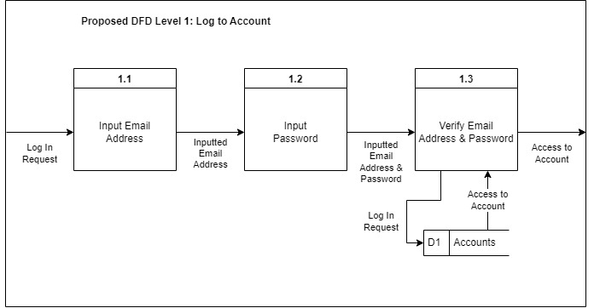

Figure 4: Proposed DFD Level 1: Log to Account

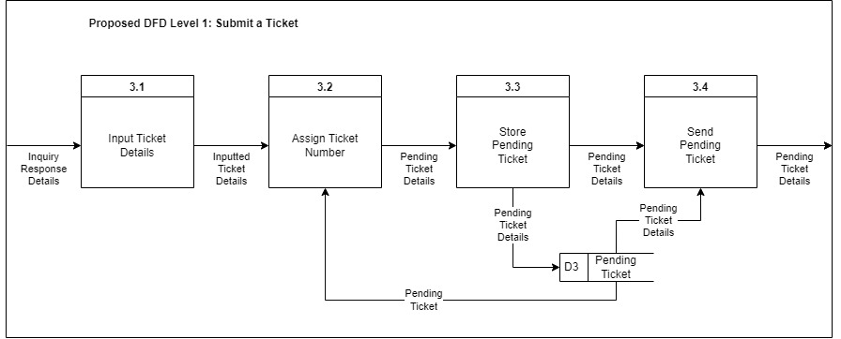

Figure 5: Proposed DFD Level 1: Submit a Ticket

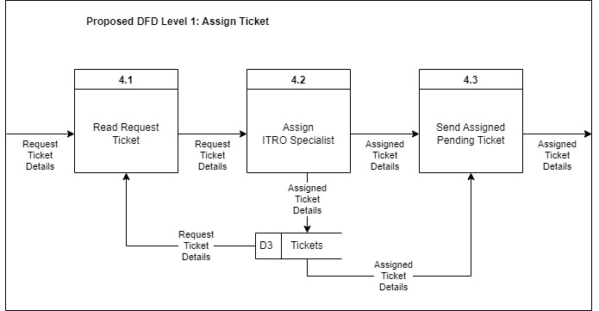

Figure 6: Proposed DFD Level 1: Assign Ticket

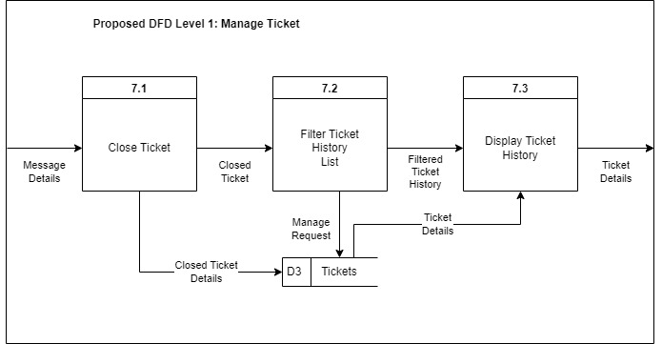

Figure 7: Proposed DFD Level 1: Manage Ticket

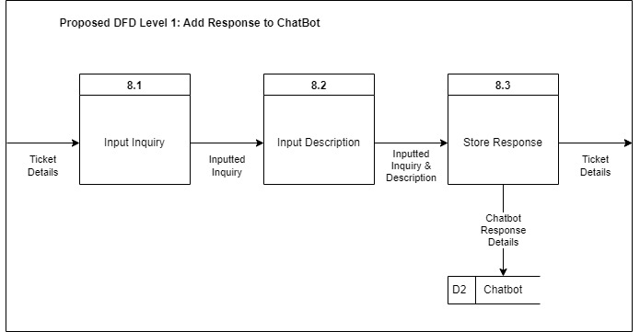

Figure 8: Proposed DFD Level 1: Add Response to ChatBot

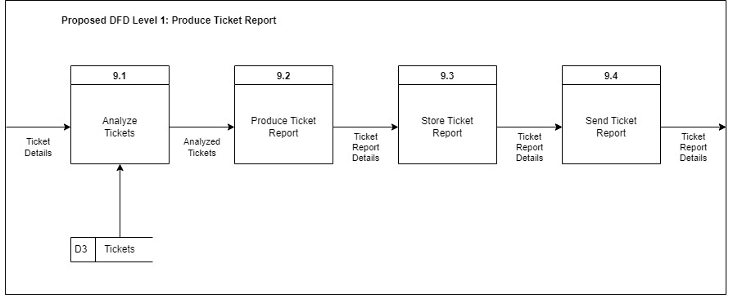

Figure 9: Proposed DFD Level 1: Produce Ticket Report

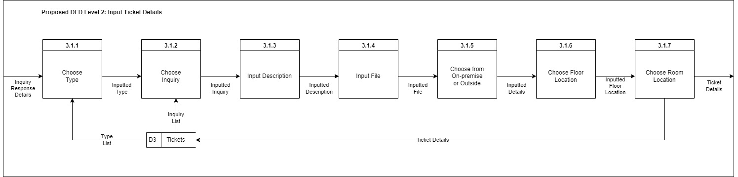

Figure 10: Proposed DFD Level 2: Input Ticket Details

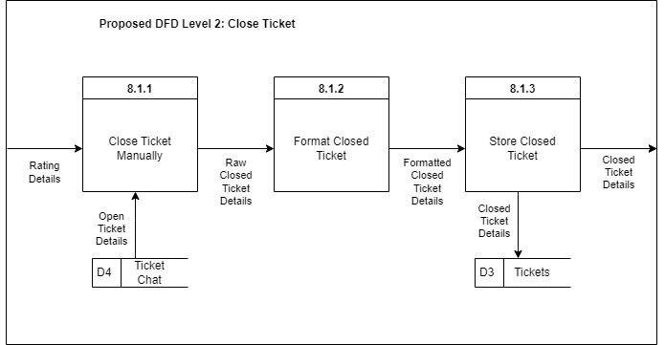

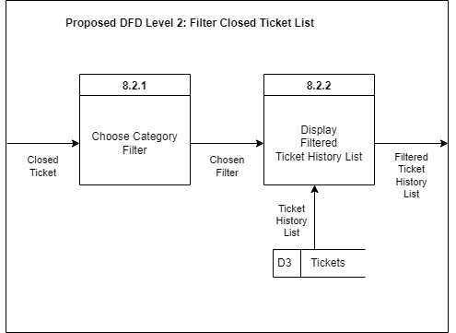Figure 11: Proposed DFD Level 2: Closed Ticket

Figure 12: Proposed DFD Level 2: Filter Closed Ticket List

### Entity-Relationship Diagrams

Figure 13: Entity-Relationship Diagram

### Activity Diagrams

Figure 14: Activity Diagrams (Report)

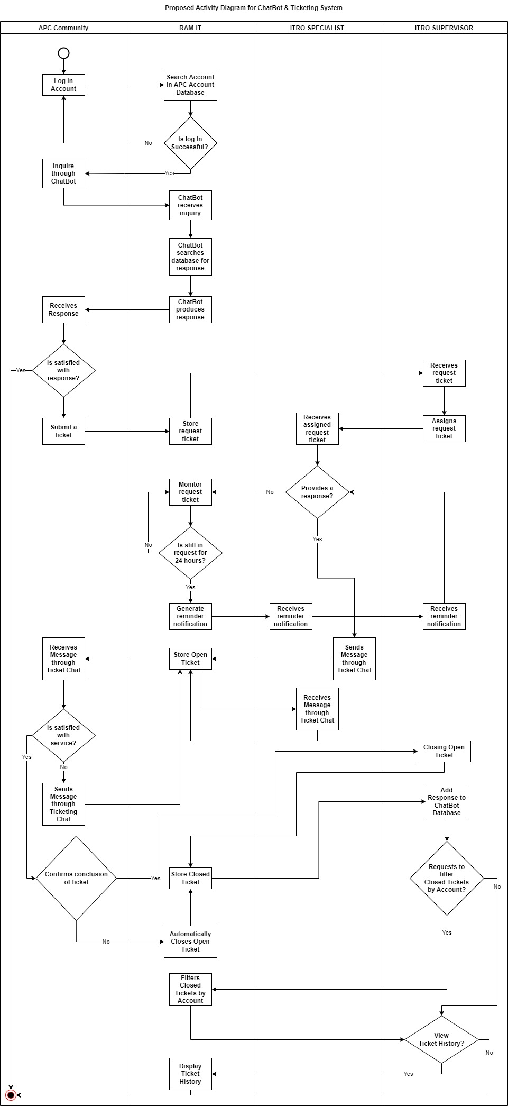

Figure 15: Activity Diagrams (ChatBot & Ticketing System) Part 1



Figure 16: Activity Diagrams (ChatBot & Ticketing System) Part 2

### Object Diagrams

Figure 17: Object Diagram

### Class Diagrams

Figure 18: Class Diagram

### Sequence Diagrams

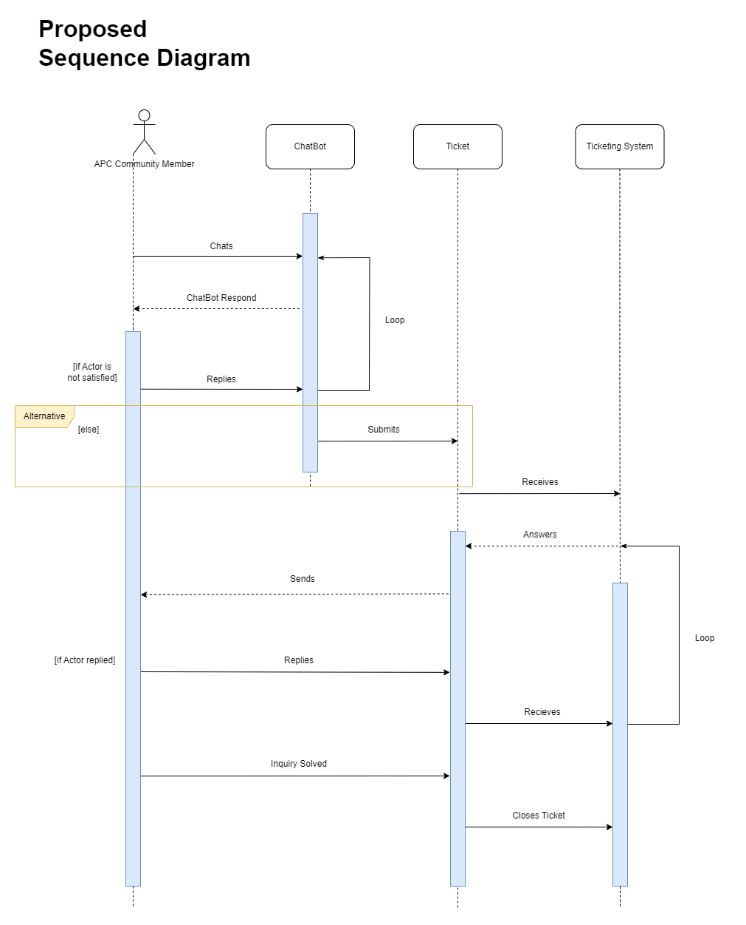

Figure 19: Proposed Sequence Diagram

### Package Diagram

Figure 20: Package Diagram

### Component Diagram

Figure 21: Component Diagram

### Deployment Diagram

Figure 22: Deployment Diagram

### Machine State Diagram

Figure 23: Machine State Diagram (ChatBot)

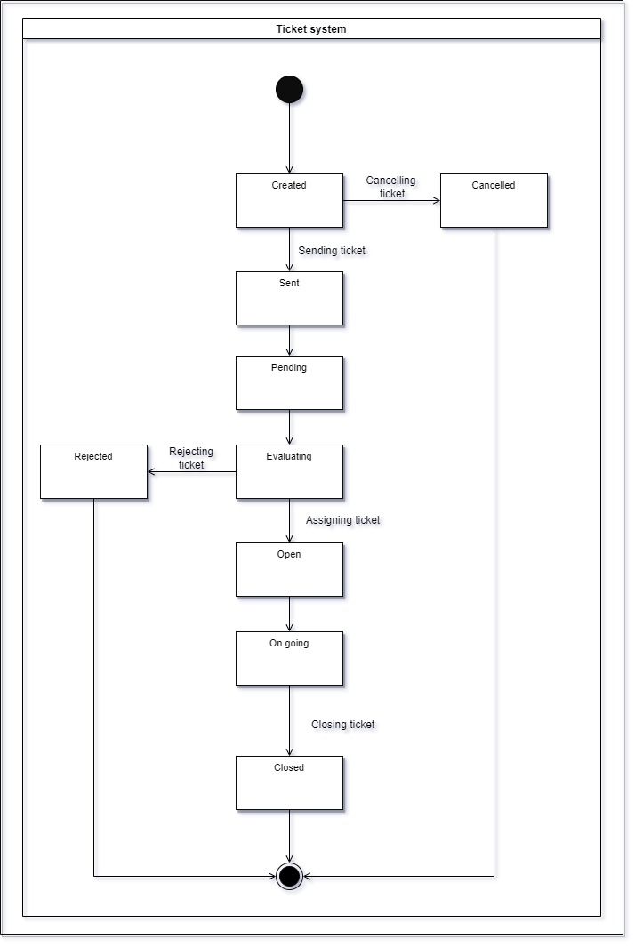

Figure 24: Machine State Diagram (Ticketing System)

# Results and Discussions

This section talks about the release plan of the proposed system as well as the mock-up and user classes and their characteristics.

## 5.1 Release Plan

|  |
| --- |
| **June 2022**  **Milestone 1**   * Wireframe   June 22, 2022 |

**Release 1**

* User can visualize the website
* User will know how the website works
* User will know the flow of the website
* User can visualize the features of the website

|  |
| --- |
| **September 2022**  **Milestone 2**   * Log In   **Milestone 3**   * Website blueprint * Website UI |

**Release 2**

* User can login
* User can see their identity
* User can view the website
* User can view the website’s UI design

|  |
| --- |
| **November 2022**  **Milestone 4**   * Ticketing System * Chat System * Notification |

**Release 3**

* User can experience the Ticketing System
* User can experience chat system
* User can be notified

|  |
| --- |
| **January 2023**  **Milestone 5**   * Open / Close Tickets * Ticket History * Generate Reports |

**Release 4**

* User can view and reply to open tickets
* User can close tickets
* User can review closed tickets
* User in the server side can filter accounts in the closed tickets
* User can see their ticket history
* User can update the database using the generated reports

|  |
| --- |
| **March 2023**  **Milestone 6**   * Chat Bot |

**Release 5**

* User can use chat bot
* Chat bot will answer based on the database

Figure 25: Release Plan

## 5.2 Prototype

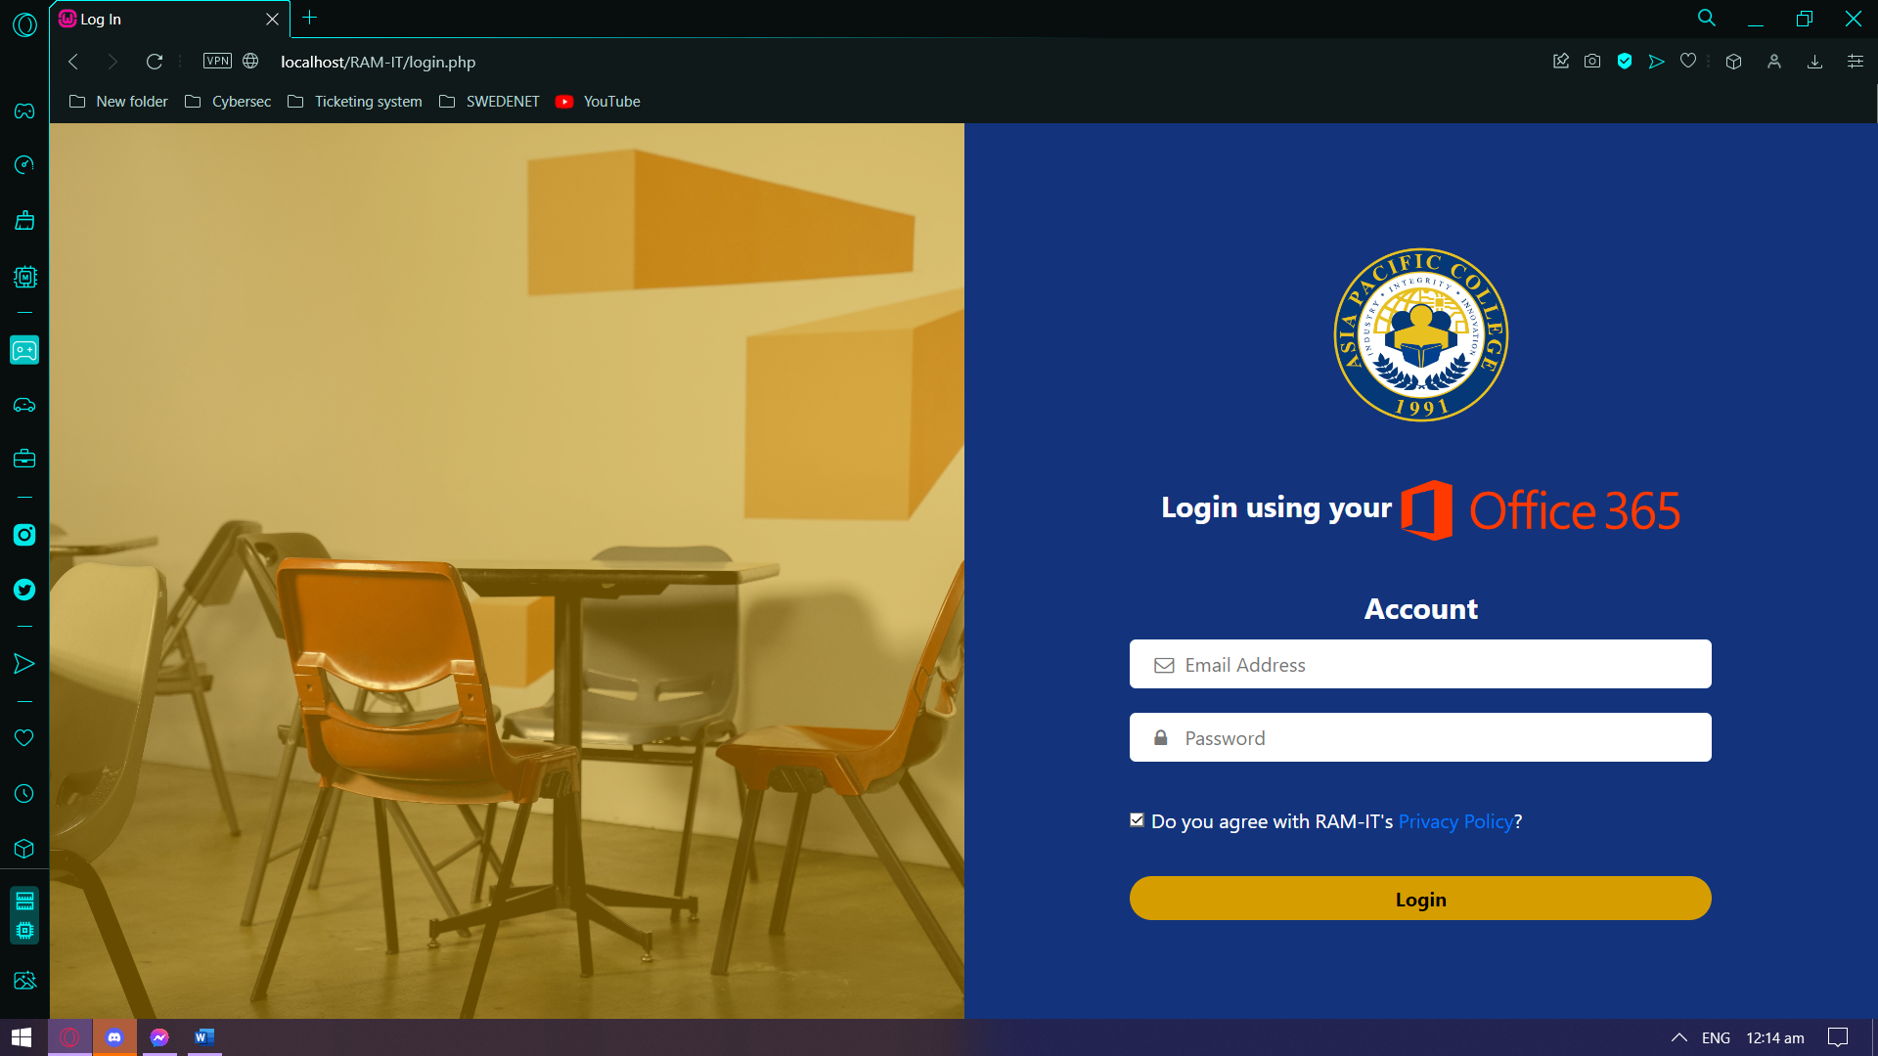

Figure 26: Prototype - Log In Page

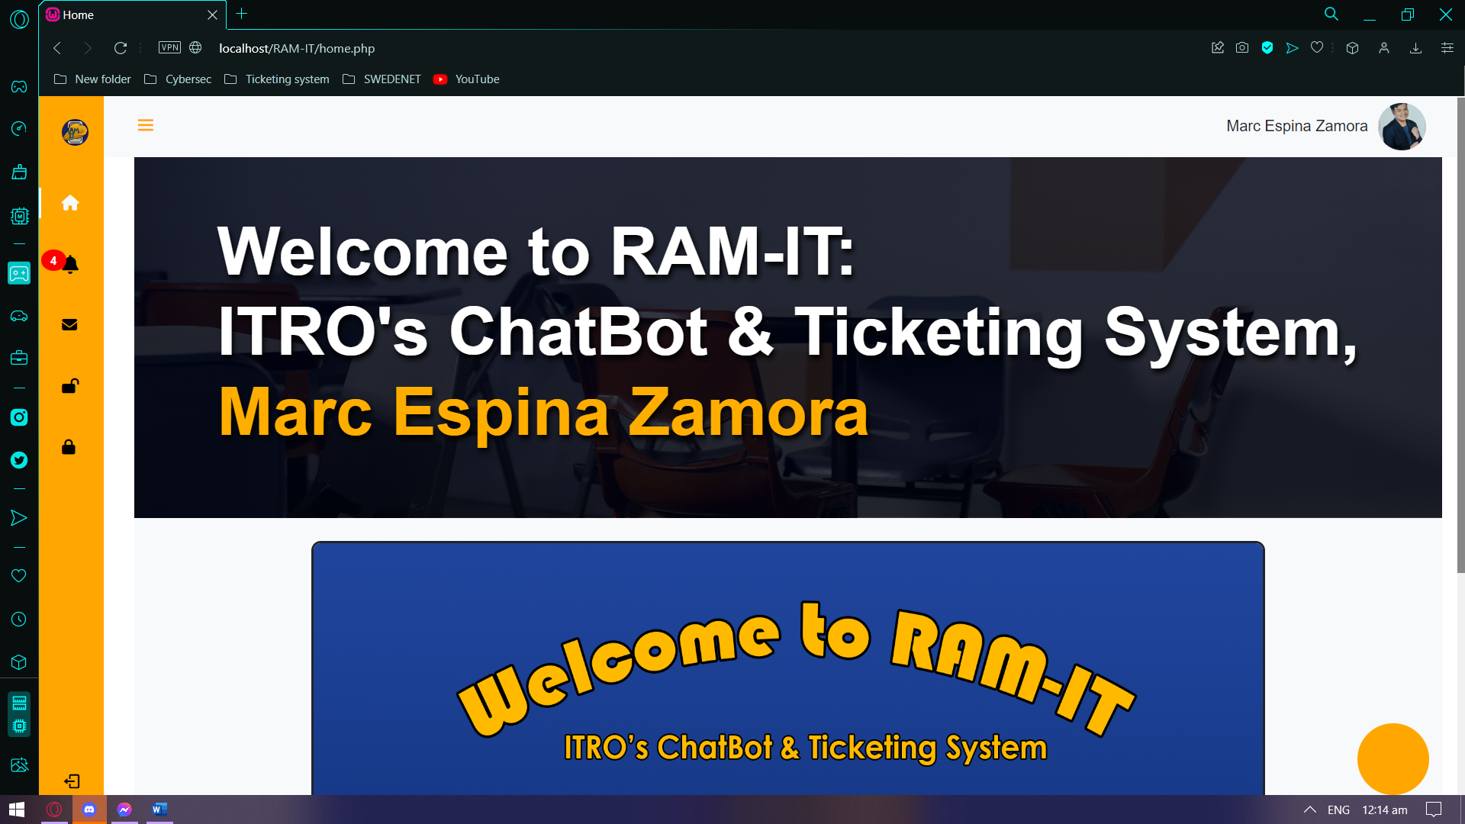

Figure 27: Prototype - Home Page (APC Community Member Side)

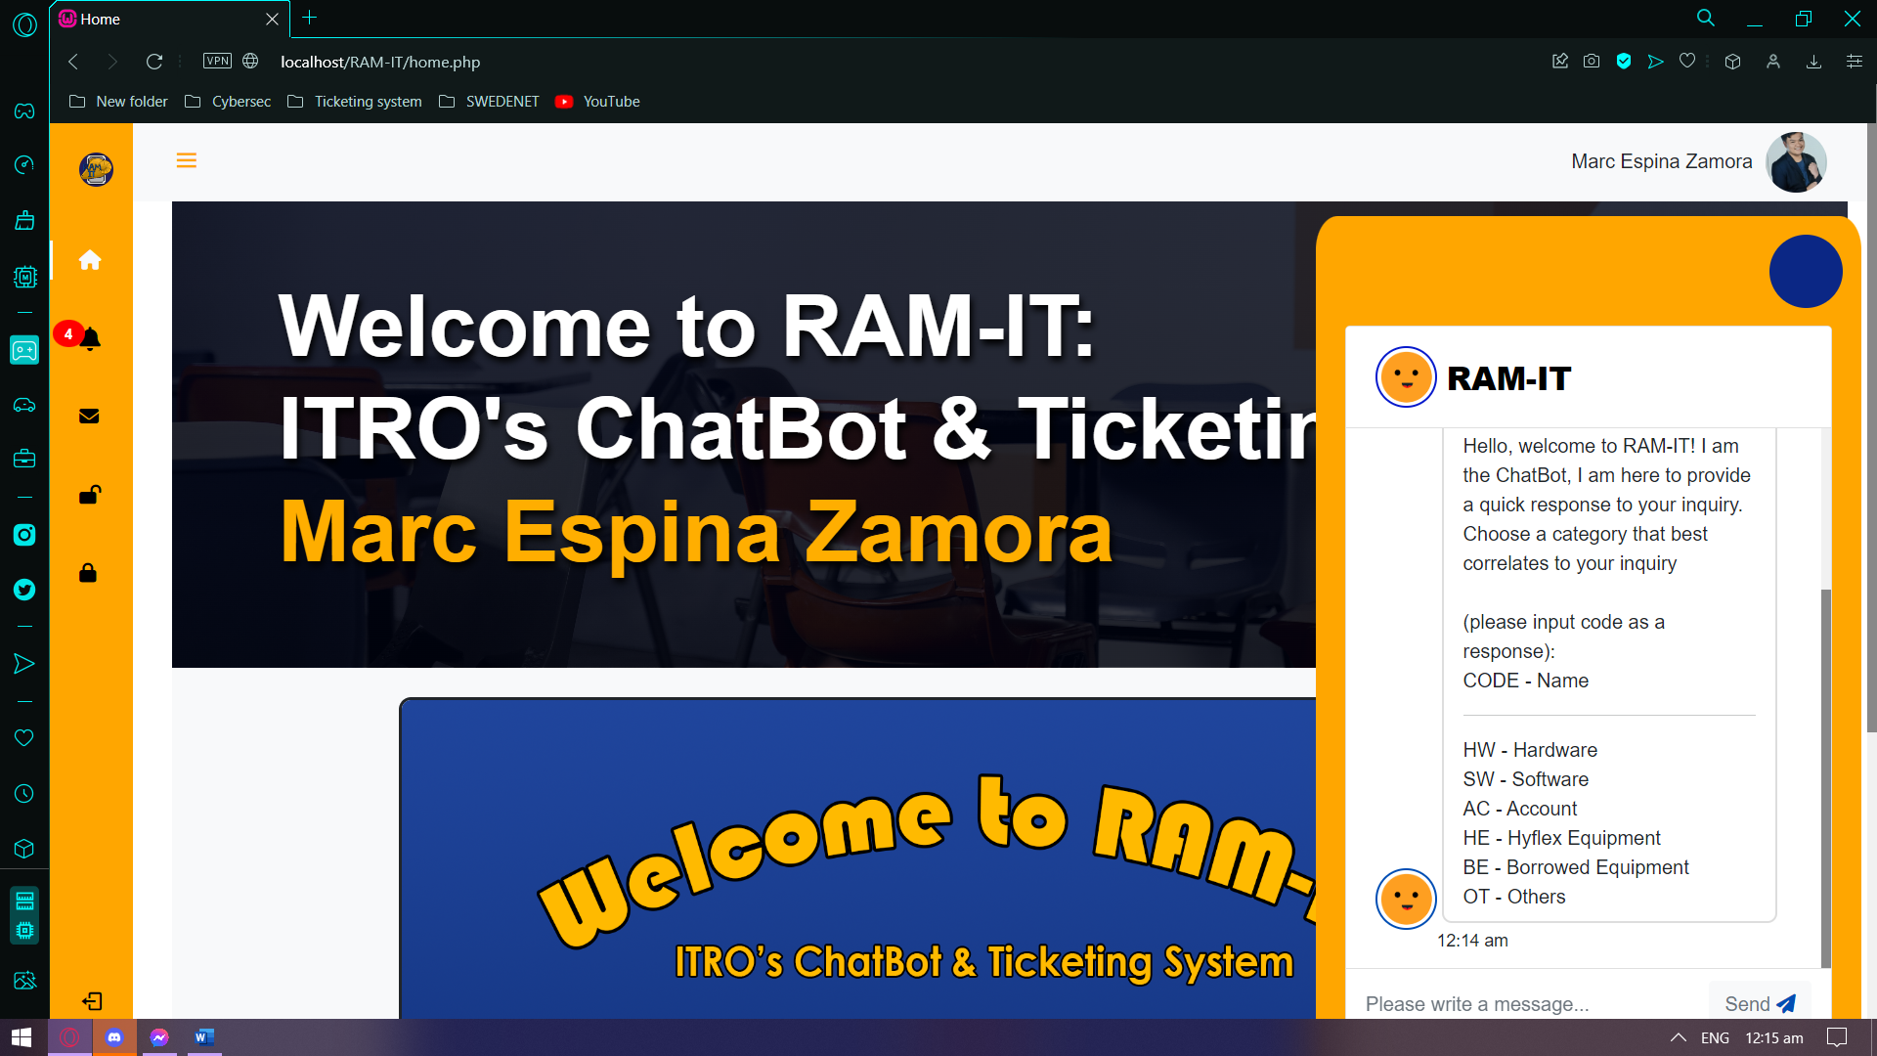

Figure 28: Prototype – ChatBot (APC Community Member Side)

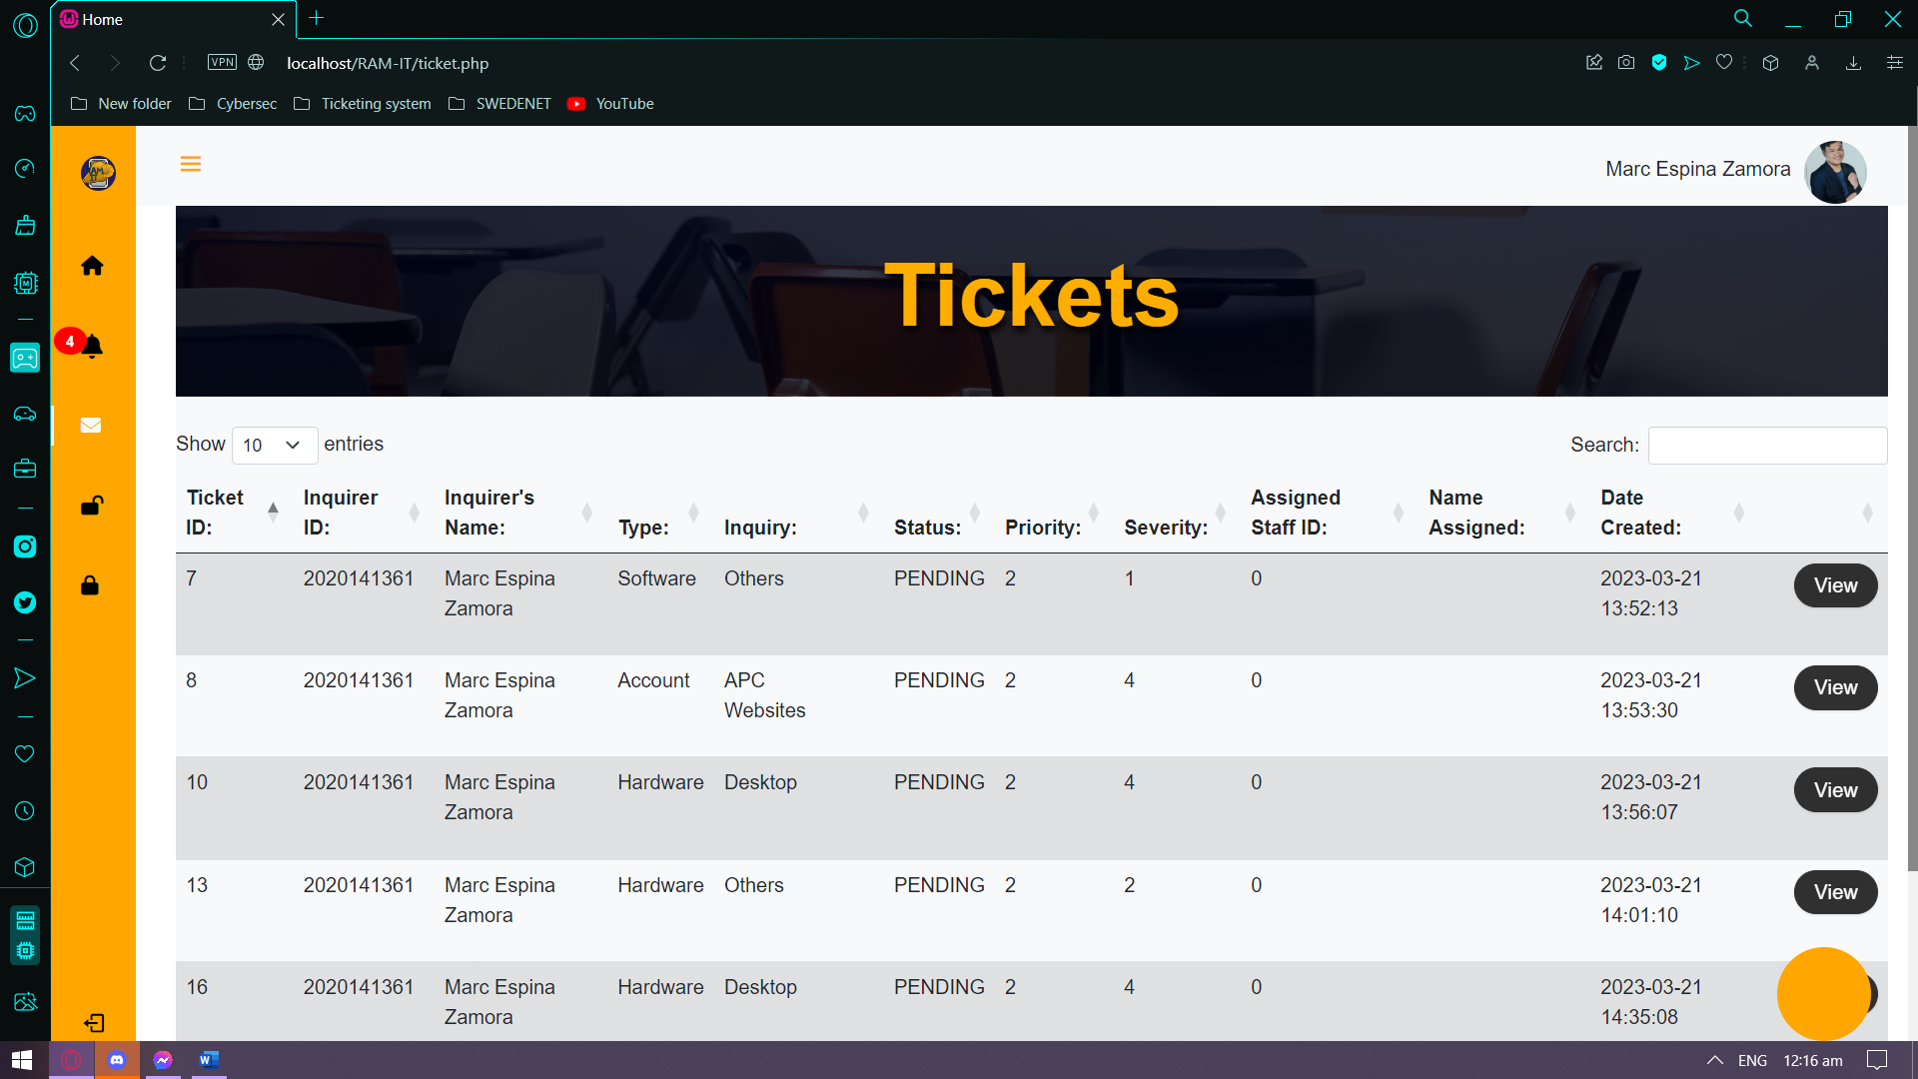

Figure 29: Prototype – Pending Tickets (APC Community Member Side)

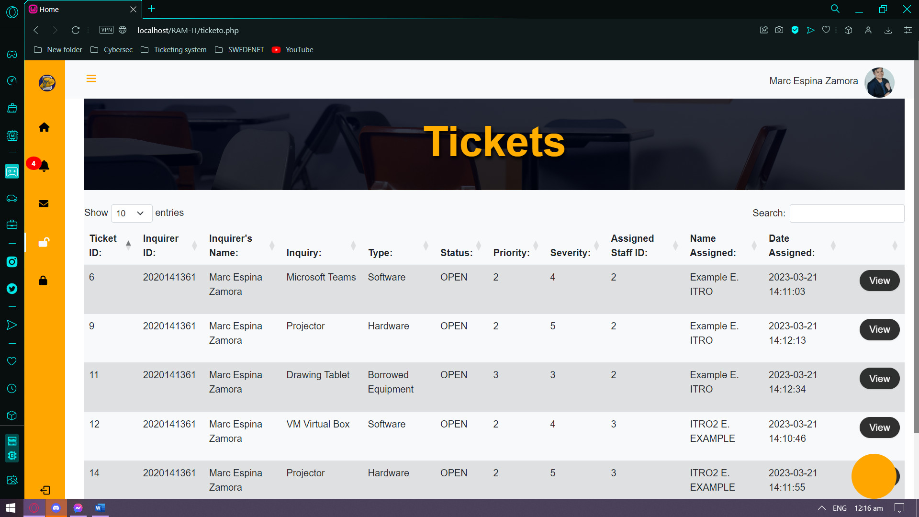

Figure 30: Prototype – Open Tickets (APC Community Member Side)

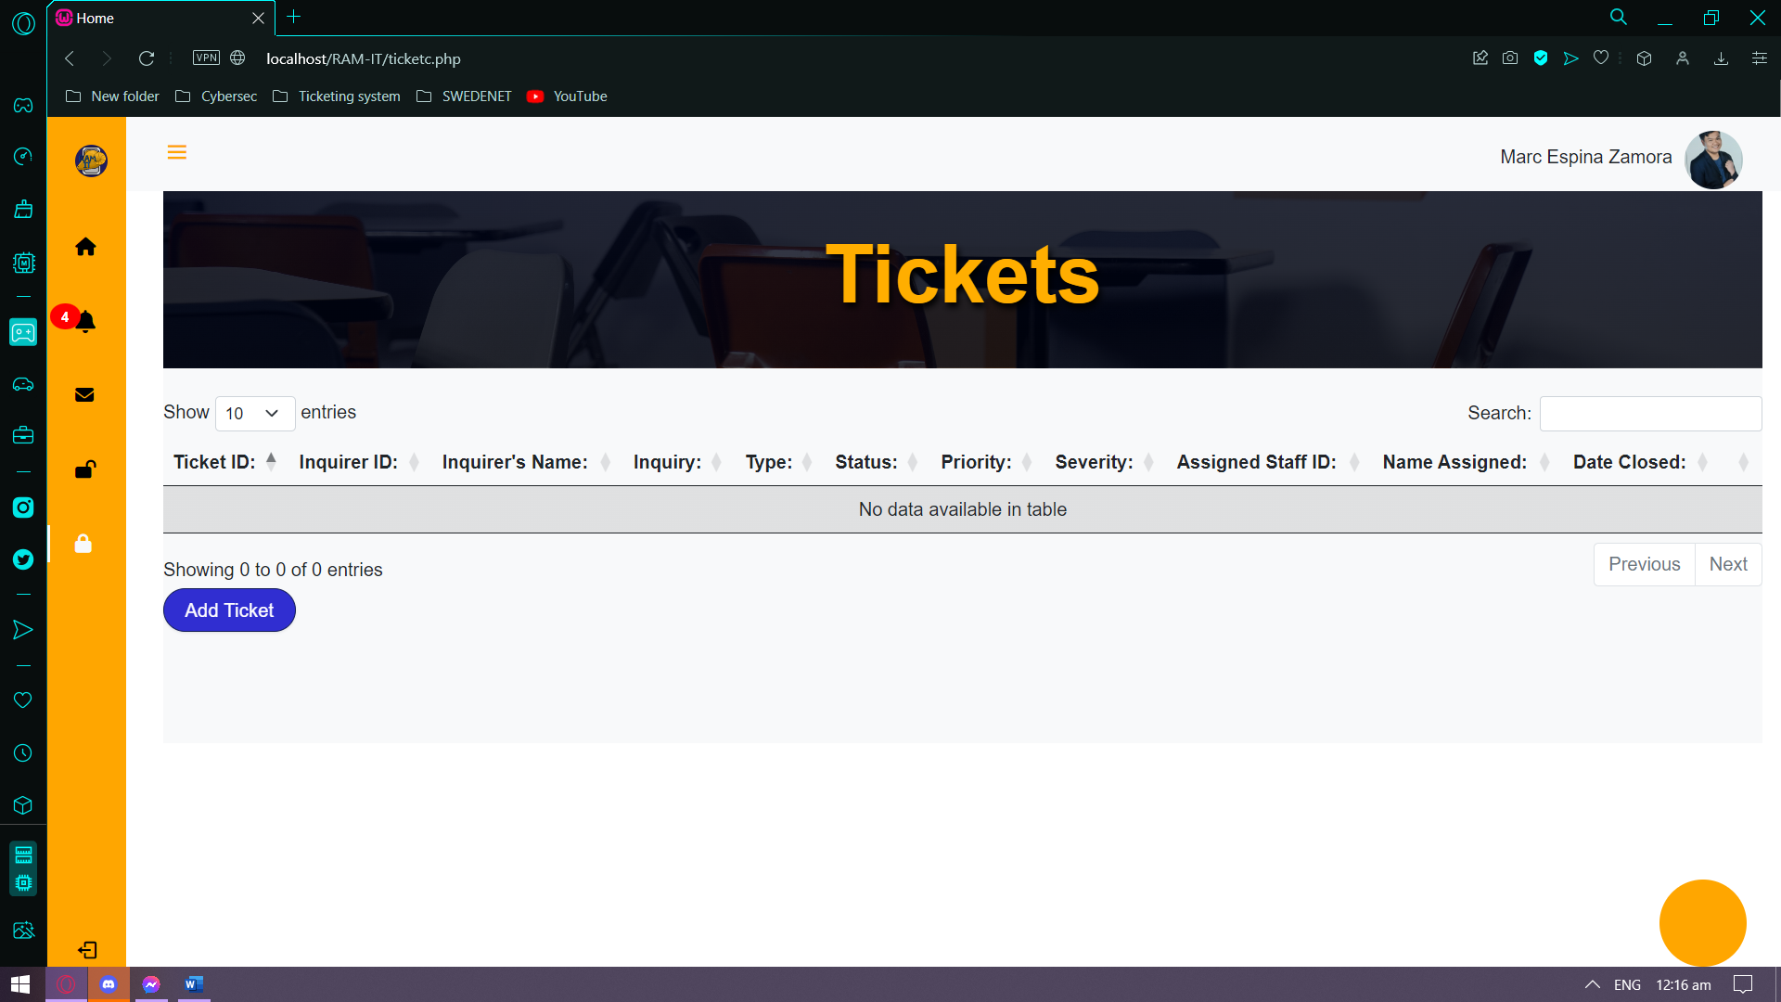

Figure 31: Prototype – Closed Tickets (APC Community Member Side)

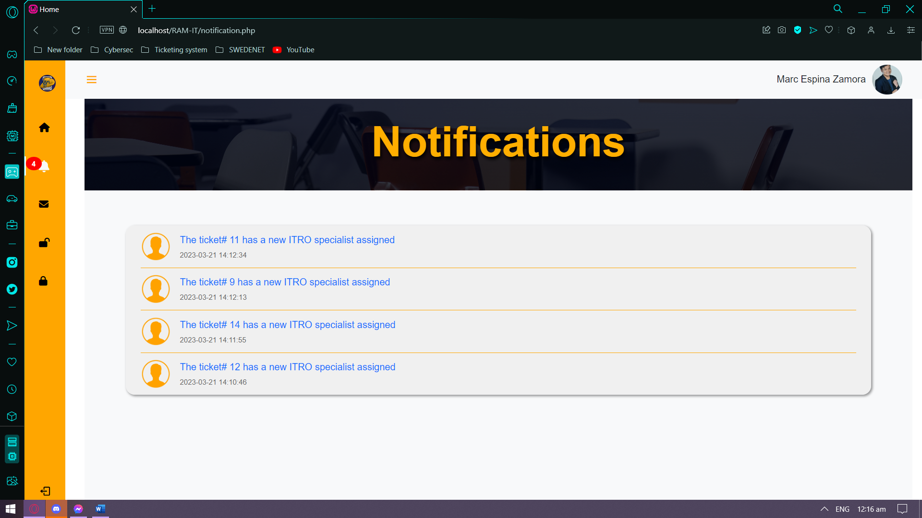

Figure 32: Prototype – Internal Notifications (APC Community Member Side)

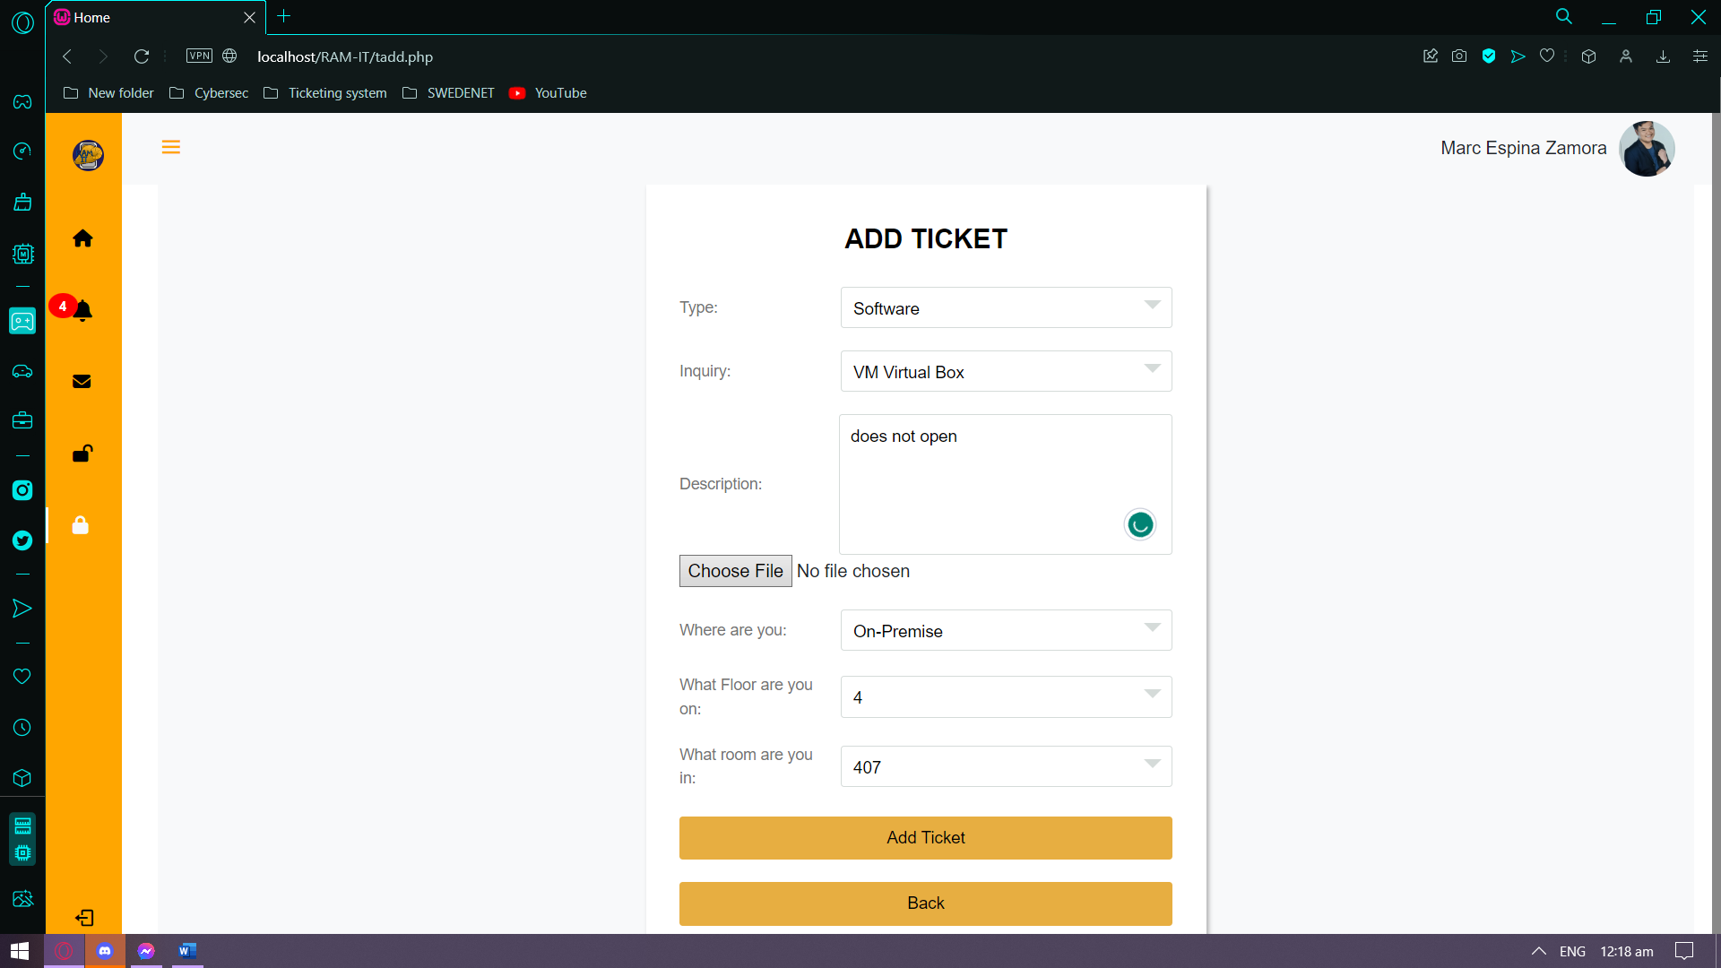

Figure 33: Prototype – Add Ticket (APC Community Member Side)

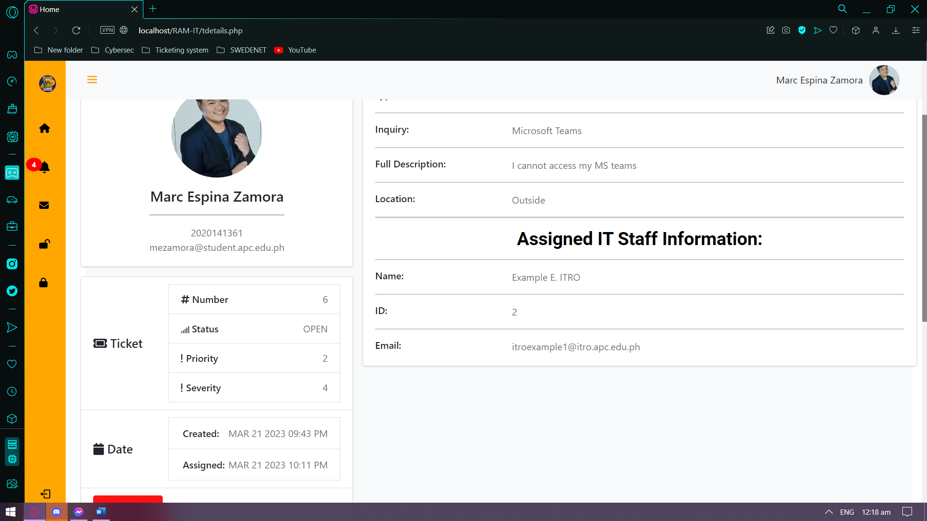

Figure 34: Prototype – Ticket Details (APC Community Member Side)

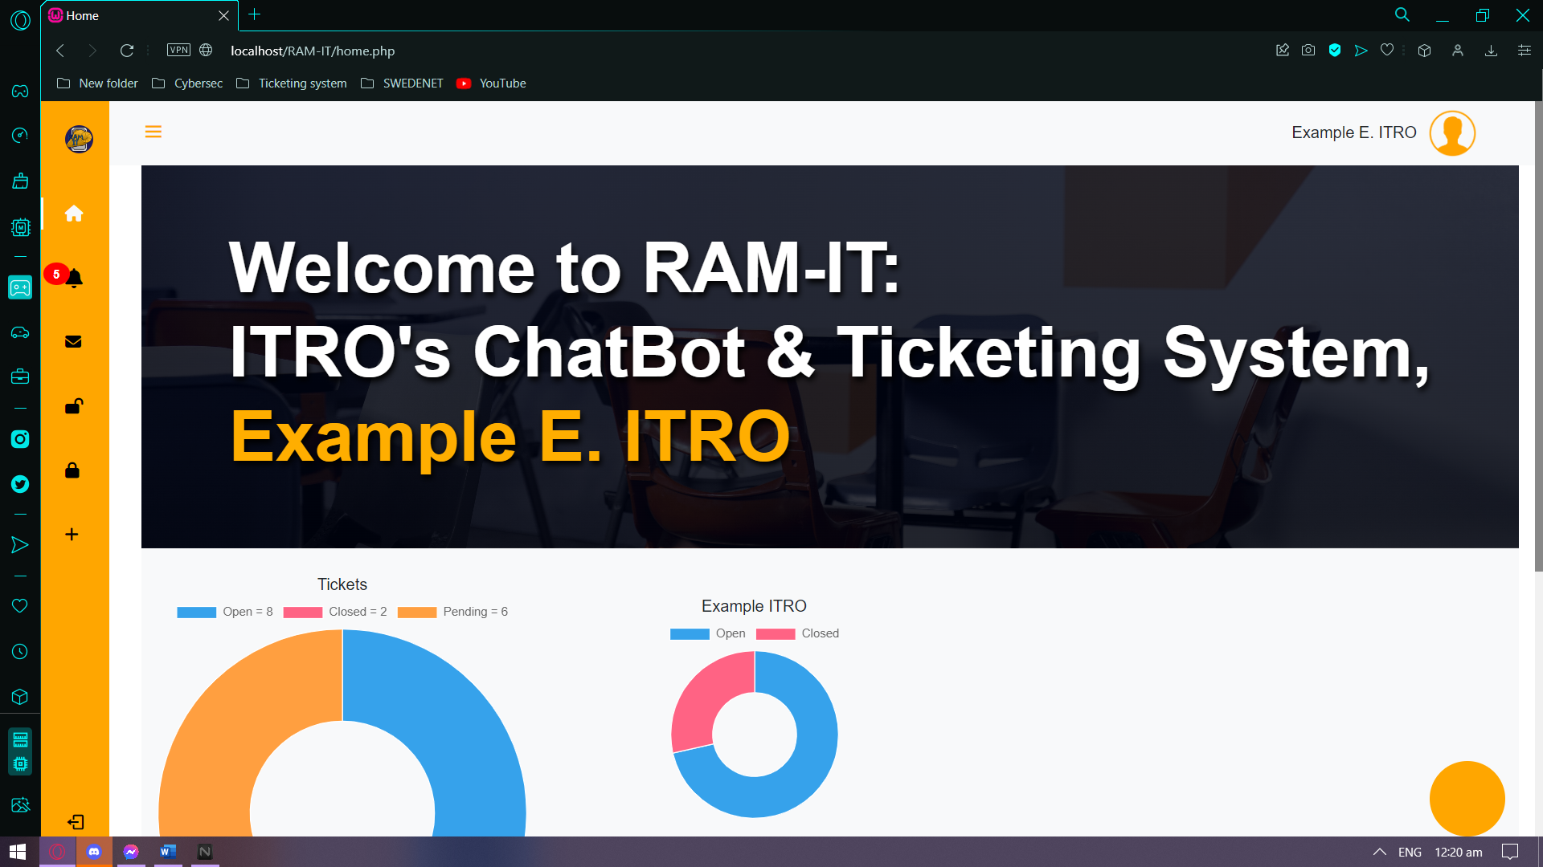

Figure 35: Prototype – Homepage (ITRO Side)

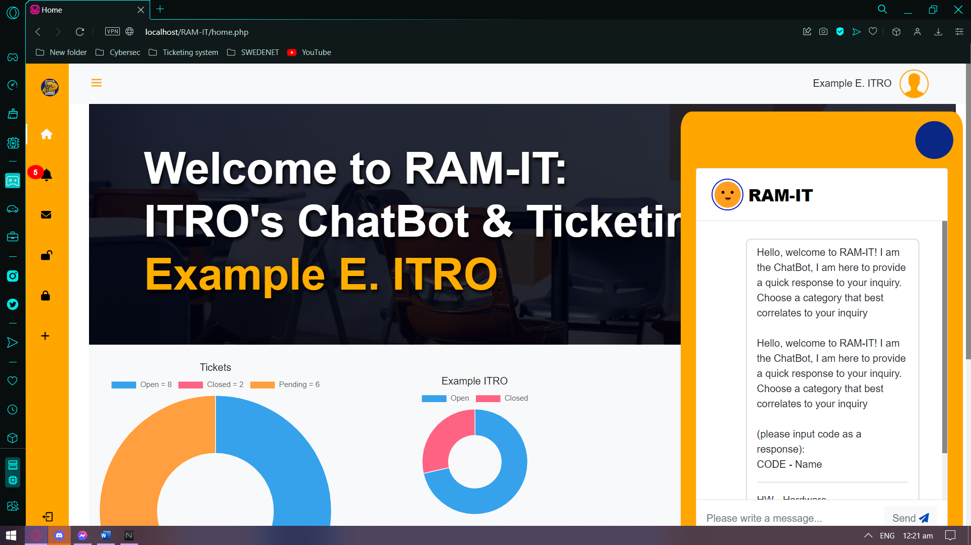

Figure 36: Prototype – ChatBot (ITRO Side)

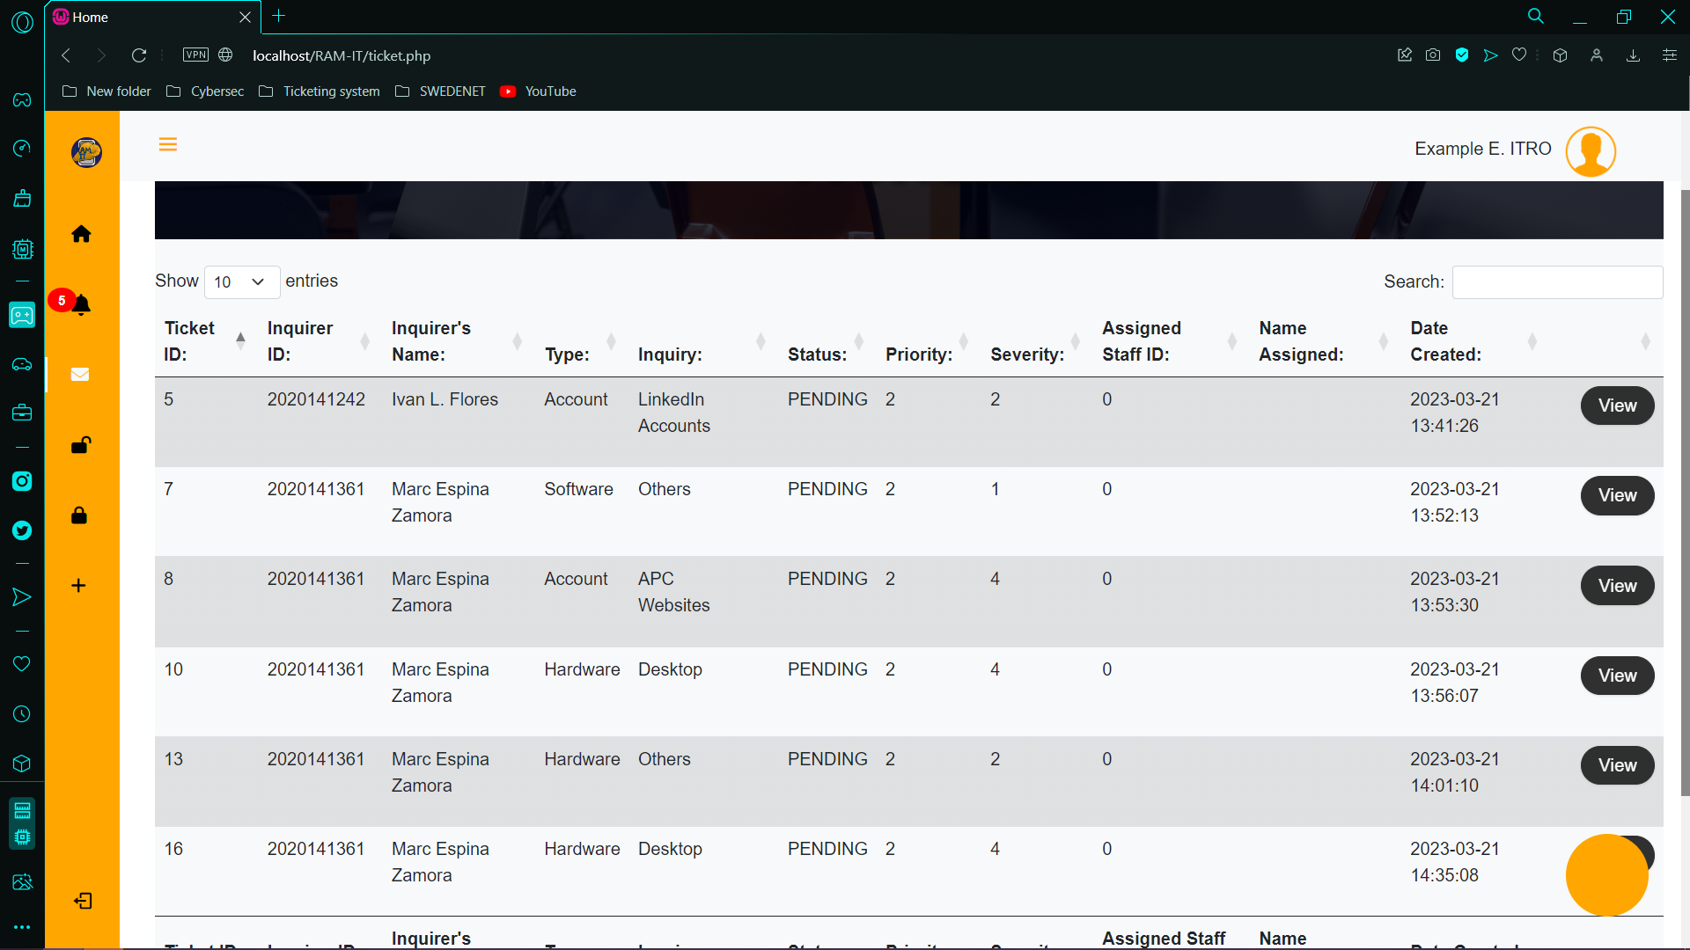

Figure 37: Prototype – Pending Tickets (ITRO Side)

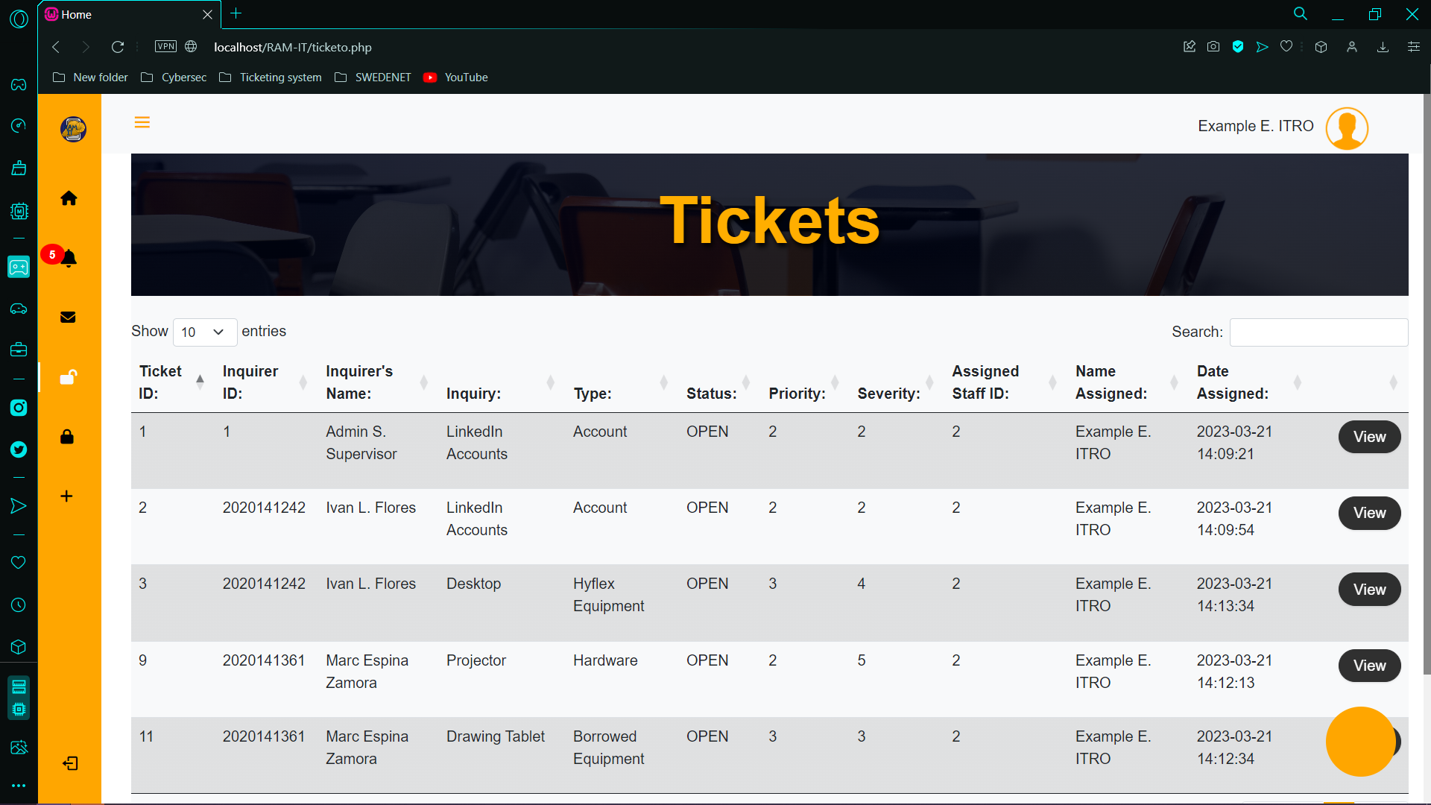

Figure 38: Prototype – Open Tickets (ITRO Side)

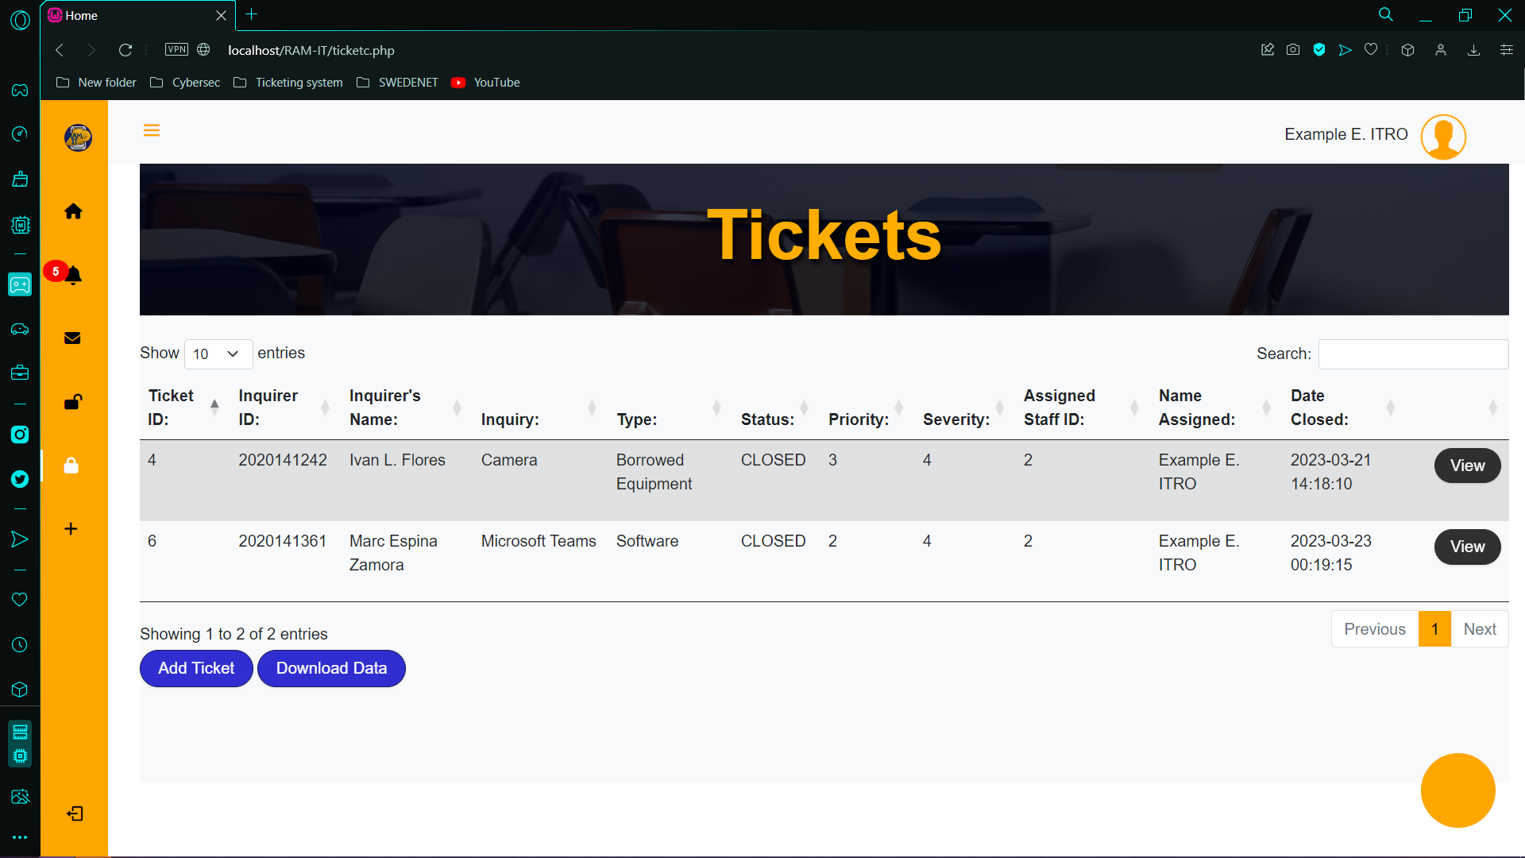

Figure 39: Prototype – Closed Tickets (ITRO Side)

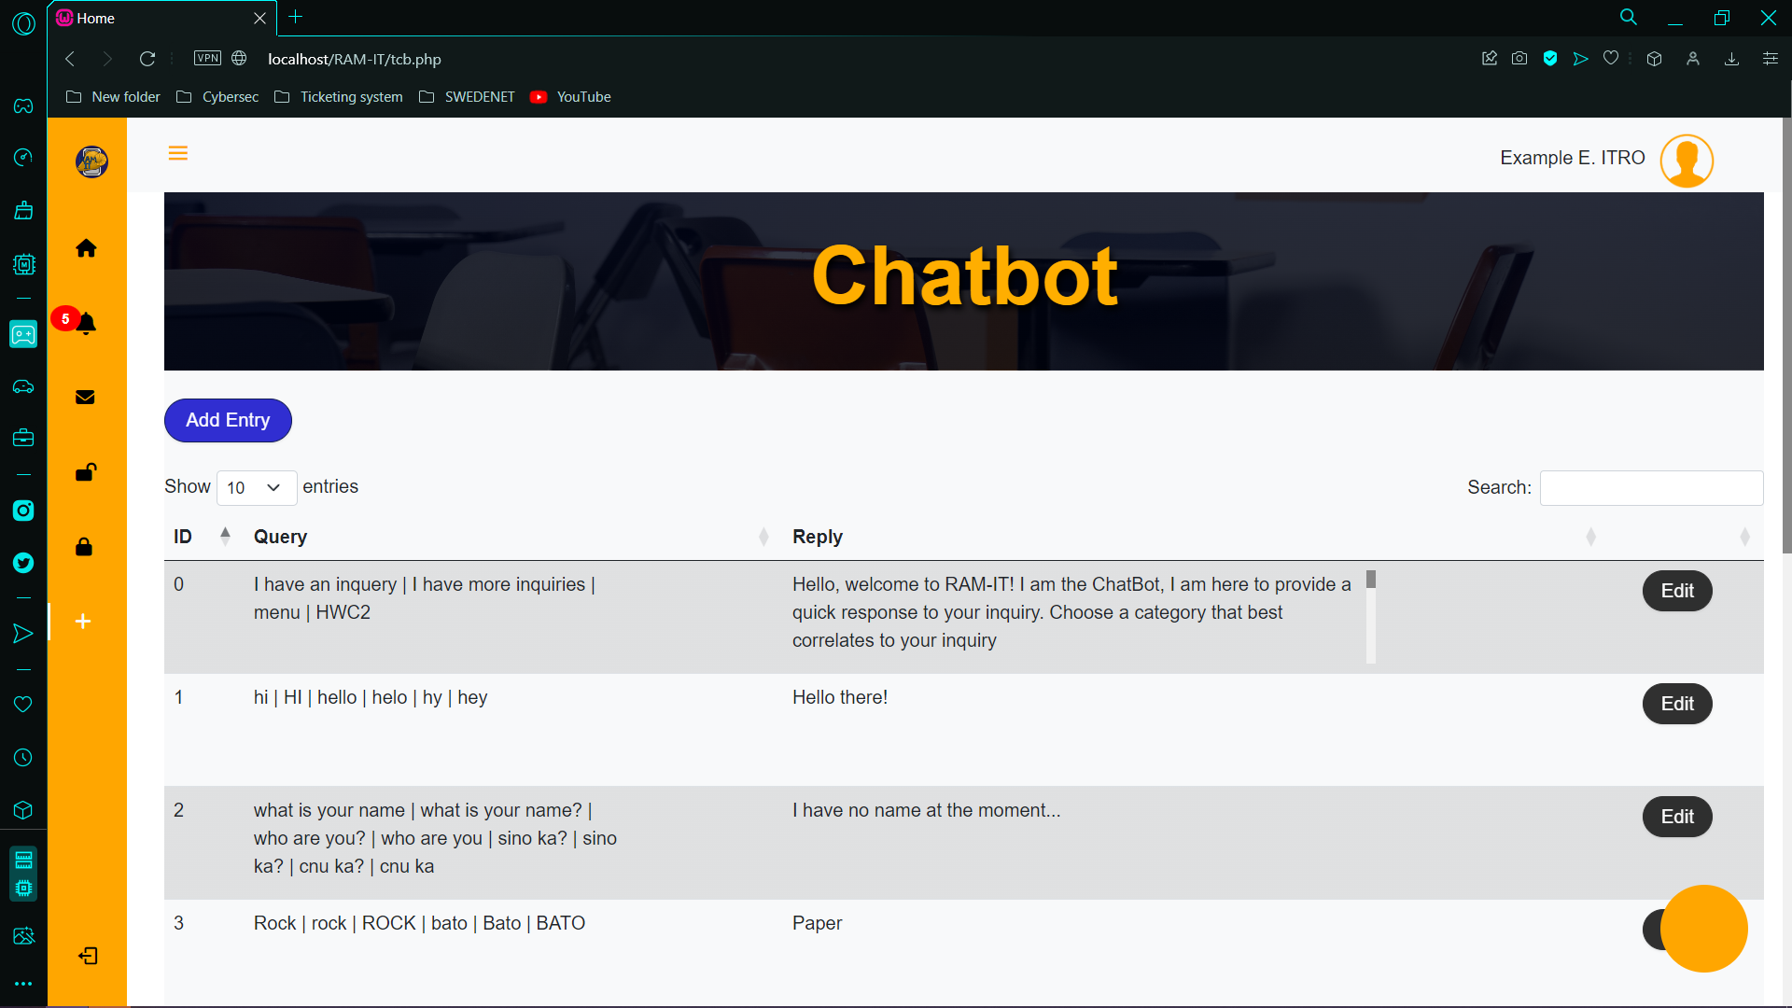

Figure 40: Prototype – ChatBot Response List (ITRO Side)

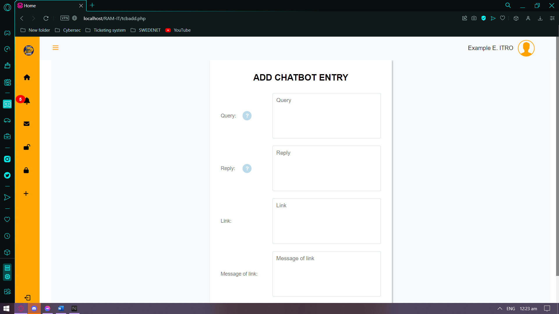

Figure 41: Prototype – Add Response to ChatBot (ITRO Side)

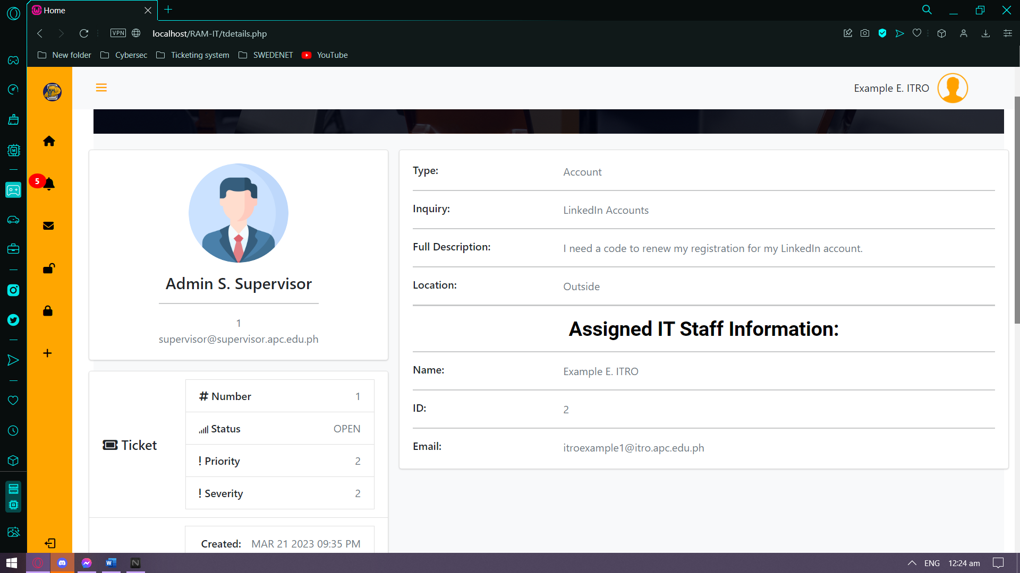

Figure 42: Prototype – Ticket Details (ITRO Side)

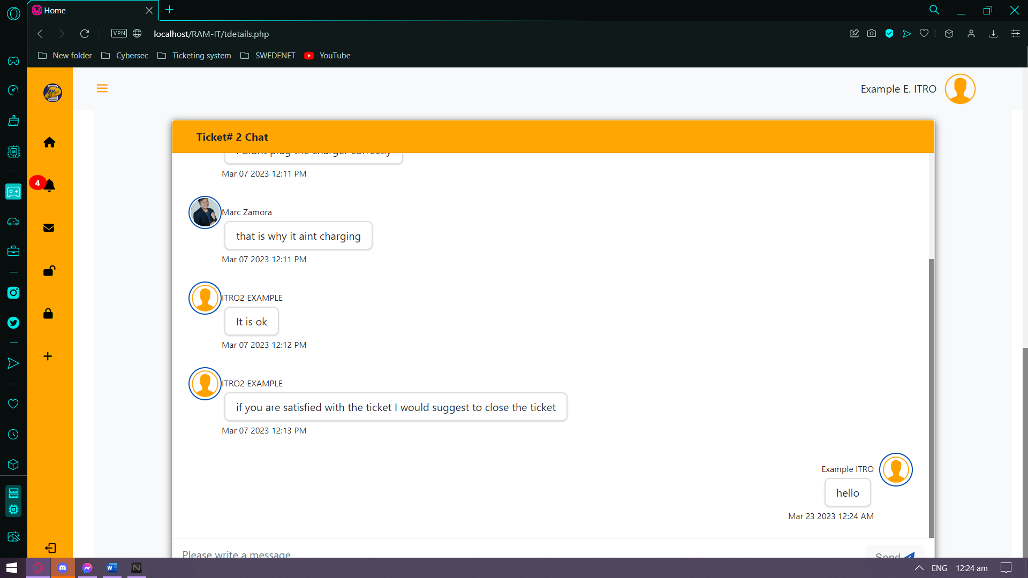

Figure 43: Prototype – Ticket Chat (ITRO Side)

## 5.3 Use Classes and Characteristics

|  |  |
| --- | --- |
| *Roles* | *Description* |
| *APC Community Member* | *The one who inquires using the RAM-IT Website. If they are not satisfied with the answer of the ChatBot, they may proceed to submit a ticket. The ticket then becomes a request ticket. The ITRO Specialist then addresses the ticket.* |
| *ITRO Supervisor* | *The one who receives the request tickets and then assigns it to an ITRO Specialist. Also, the one to make sure all the tickets handled by the ITRO Specialists are answered within 24 hours.* |
| *ITRO Specialist* | *The one who provides service to the APC Community Member by communicating with them inside a ticket system chat.* |

Table 15: Use Classes and Characteristics

# Conclusion & Recommendation

## 6.1 Conclusion

What the proponents finished is the research on the feasibility and viability of having a ticketing system implemented to benefit the ITRO. The proposed deliverables of the proposed project are accomplished during the duration of the monthly sprint. The decision of proponents, the client, the project adviser, and the consultant is to reevaluate and revise the proposal and the main features of the previous project. Likewise, the proposed ticketing system has the same intent and similar goal of implementing an IT solution to help aid the current systems of ITRO regarding APC community's inquiries. The proponents' goal is to create a working ticketing system with additional supporting features indicated on the proposal during the development.

## 6.2 Recommendation

1. If there is no internet, an alternative solution such as contacting the ITRO through SMS is provided.

# References

|  |  |
| --- | --- |
| [1] | Digital Class World , "Importance of information technology in today’s world," Digital Class World , [Online]. Available: https://www.digitalclassworld.com/blog/importance-of-information-technology/#:~:text=Information%20technology%20helps%20to%20build,%2C%20storage%2C%20and%20efficient%20communication. [Accessed September 2022]. |
| [2] | T. G. D. a. J. F. e. C. M. C. Ferreira, "An In-Depth Study of Mobile Ticketing Services in Urban Passenger Transport: State of the Art and Future Perspectives," IGI Global , 2020. [Online]. Available: https://www.igi-global.com/chapter/an-in-depth-study-of-mobile-ticketing-services-in-urban-passenger-transport/249113. [Accessed September 2022]. |
| [3] | Freshworks Inc., "Freshworks: About us," Freshworks Inc., [Online]. Available: https://www.freshworks.com/company/about/?source=freshdesk&medium=referral&campaign=fdesk_footer_main. [Accessed September 2022]. |
| [4] | Spiceworks, "What is Spiceworks Cloud Help Desk?," Spiceworks, [Online]. Available: https://www.spiceworks.com/free-cloud-help-desk-software/. [Accessed September 2022]. |
| [5] | J. R. L. S. V. Omana, "Student Helpdesk System," IJESC, March 2017. [Online]. Available: https://ijesc.org/upload/59d8ff563e7788efb55a2dc75d70d862.Student%20Helpdesk%20System.pdf. [Accessed September 2022]. |
| [6] | Santa Ana College, "The Student Help Desk," Santa Ana College, [Online]. Available: https://www.sac.edu/StudentServices/digital-dons/Pages/The-Student-Help-Desk.aspx. [Accessed September 2022]. |
| [7] | Office of Educational Technology, "Students as Tech Support," Office of Educational Technology, [Online]. Available: https://tech.ed.gov/stories/students-as-tech-support/. [Accessed September 2022]. |
| [8] | D. S. M. G. R. C. Patricia O. Calora, "Exploring the Potential of a Ticketing-Based Student Support System for Open and Distance," December 2020. [Online]. Available: https://ijodel.com/wp-content/uploads/2021/08/004_Calora_et_al.pdf. [Accessed 2022 September]. |
| [9] | J. Giblett, "How chatbots are used in schools," Digistorm, 5 October 2021. [Online]. Available: https://insights.digistorm.com/en-au/chatbots-in-schools?hsLang=en-au. [Accessed September 2022]. |
| [10] | L. Pappano, "College Chatbots, With Names Like Iggy and Pounce, Are Here to Help," The New York Times, 8 May 2020. [Online]. Available: https://www.nytimes.com/2020/04/08/education/college-ai-chatbots-students.html. [Accessed September 2022]. |
| [11] | P. J. A. C. B. A. M. E. F. C.-L. L. P. P. a. M. C. A. Joane V. Serrano, "Ask Iska and IskOU:Analysis of UPOU's Chatbot for Information Support Services," June 2021. [Online]. Available: https://www.google.com/url?sa=t&rct=j&q=&esrc=s&source=web&cd=&ved=2ahUKEwiTjpOxgr76AhXYe94KHcNlAvIQFnoECBAQAQ&url=https%3A%2F%2Fijodel.com%2Fwp-content%2Fuploads%2F2021%2F09%2F005_Serrano_et_al.pdf&usg=AOvVaw3eL21x2CUgFPjnVNjbQsw2. [Accessed September 2022]. |
| [12] | J. Laukkonen, "What Is a Notification System?," Easytechjunkie, 20 September 2022. [Online]. Available: https://www.easytechjunkie.com/what-is-a-notification-system.htm. [Accessed September 2022]. |
| [13] | AIRSHIP, "Web Push Notifications Explained," AIRSHIP, [Online]. Available: https://www.airship.com/resources/explainer/web-push-notifications-explained/#:~:text=Web%20push%20notifications%20are%20notifications,desktop%20web%20and%20mobile%20web.. [Accessed September 2022]. |
| [14] | C. Lowe, "Web Push Notifications Mastery Guide," Insider, 2 December 2019. [Online]. Available: https://useinsider.com/what-is-web-push-notification/. [Accessed September 2022]. |
| [15] | SendPulse, "What is an SMS Notification? - Guide," SendPulse, 2 September 2022. [Online]. Available: https://sendpulse.com/support/glossary/sms-notification. [Accessed September 2022]. |
| [16] | SPARKPOST, "What product teams need to know about email notifications," SPARKPOST, [Online]. Available: https://www.sparkpost.com/academy/user-engagement/getting-started-email-notifications/. [Accessed September 2022]. |
| [17] | S. Peek and S. Angeles, "What Is Agile Scrum Methodology?," Business News Daily, 22 December 2021. [Online]. Available: https://www.businessnewsdaily.com/4987-what-is-agile-scrum-methodology.html. [Accessed 4 June 2022]. |

# Appendices

## Appendix A: Project Vision

**For** The APC Community

**Who** needs to have a better way to seek customer support from ITRO

**The** RAM-IT **is** ITRO’s ChatBot and Ticketing System Website

**That** requires the users to log in using the APC’s Microsoft account to access the following features: ChatBot and Ticketing System.

**Unlike** ITRO’s Email

**Out Product** has tendencies to accumulate multiple inquiries due to its direct communication.

## Appendix B: Roles & Responsibilities

|  |  |  |  |  |
| --- | --- | --- | --- | --- |
| **Aloya, Jayson** | **Langcauon, John Christopher** | **Prion, Jan Gabriel** | **Sajul, Marc Julian** | **Zamora, Marc** |
| *Scrum Master* | *Documentation / Product Developer* | *Product Developer* | *Product Owner* | *Main Programmer* |
| Statement of the Problem | Executive Summary | Project Context | Scope & Limitations | RRL |
| Objectives | Current Technical Background | Significance of the Project | Proposed Technical Background | Use Case Full Description |
| Event Table | User Stories | Conclusion | User Stories | List of Figures |
| Use Case Diagram | Video Editing | Comments Matrix | Gap Analysis | List of Tables |
| Context Diagram | Presentation Deck | Package Diagram | Entity-Relationship Diagram | References |
| Data Flow Diagrams | Deployment Diagram | Contingency Plan | Object Diagram | Team Meetings |
| Activity Diagrams | Improvement Matrix | Project Vision & Scope Document | Class Diagram | Machine State Diagram |
| Use Classes and Characteristics | Project Charter | Software Requirement Specification | Release Plan | Contingency Plan |
| Project Vision | Change Management Plan | Quality Plan | Mock-Up | Prototype Back End |
| Roles & Responsibilities |  |  | Product Roadmap |  |
| Presentation Deck |  |  | Comments Matrix |  |
| Comments Matrix |  |  | Sequence Diagram |  |
| Component Diagram |  |  | Prototype Front End |  |
| Package Diagram |  |  | Statement of Work |  |
| Project Charter |  |  | Test Cases |  |
| Activity List |  |  | Video Teaser Edit |  |
| Work Breakdown Structure |  |  |  |  |
| User Review |  |  |  |  |

Table 16: Roles & Responsibilities

## Appendix C: Product Roadmap

|  |  |  |  |
| --- | --- | --- | --- |
| **June 2022**  **Milestone 1**   * Wireframe   June 22, 2022 | **September 2022**  **Milestone 2**   * Website blueprint * Website UI   **Milestone 3**   * Log In | **November 2022**  **Milestone 4**   * Ticketing System * Chat System * Notification System | **January 2023**  **Milestone 5**   * Open / Close Tickets * Ticket History * Generate Reports * Filter System |

|  |
| --- |
| **March 2023**  **Milestone 6**   * Chat Bot |

Figure 44: Product Roadmap

## Appendix D: Source Code

Figure 45: Source Code Github

<https://github.com/MarcZamora/RAM-IT>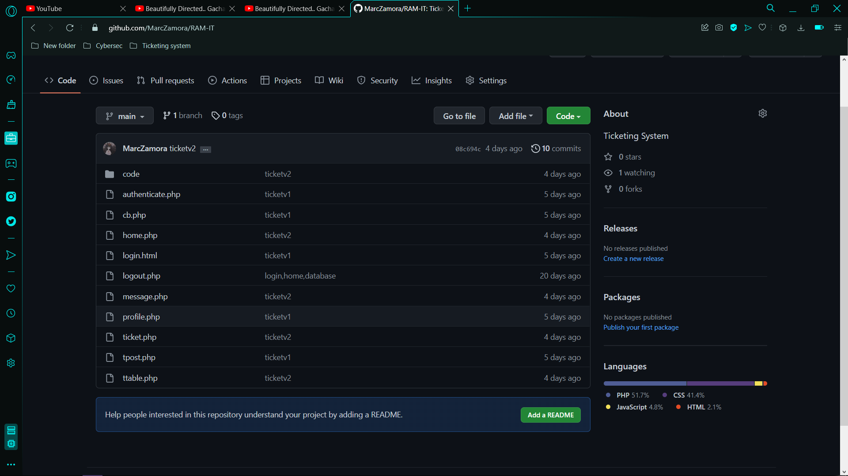

## Appendix E: Contingency Plan

|  |  |  |  |  |  |  |
| --- | --- | --- | --- | --- | --- | --- |
| **Event** | **Likelihood of Occurring** | **Impact on Business** | Priority (1-5) | **Solution to Deal with Event** | **How** | **Who** |
| High Traffic in Website | High | Moderate | 4 | Slow down the amount of incoming traffic | Make incoming traffic slower by queueing while handling the current traffic inside the website | ITRO |
| Work suspension because due to calamity | Medium | Low | 3 | Resume of operations remotely | Staff will work at home | ITRO Specialist |
| Key Staff Member/s is not available (Ill/Quit | Medium – Low | High | 3 | Replacement to position and reassignment of workload | ITRO admin will re-assign work to another staff | ITRO Supervisor |
| Server is unable to resume (Damage/Maintenance) | Low | High | 5 | Prepare backup data | Run a temporary remote server | ITRO |
| Unable to login Microsoft APC Account (Forgot Account Details/Any account problem related) | Medium | Low | 1 | ITRO will guide the student to access their account. | The APC Community Member that has a problem with their account will contact the ITRO for guidance. | ITRO Specialists |
| No Internet | Medium | Medium – High | 5 | ITRO will encourage the APC Community Members to contact them via SMS. | This will be a practice that will be spread to the APC Community Member, telling them that there is no internet, ITRO can be contacted via SMS. | ITRO |

Table 17: Contingency Plan

## Appendix F: Report Example

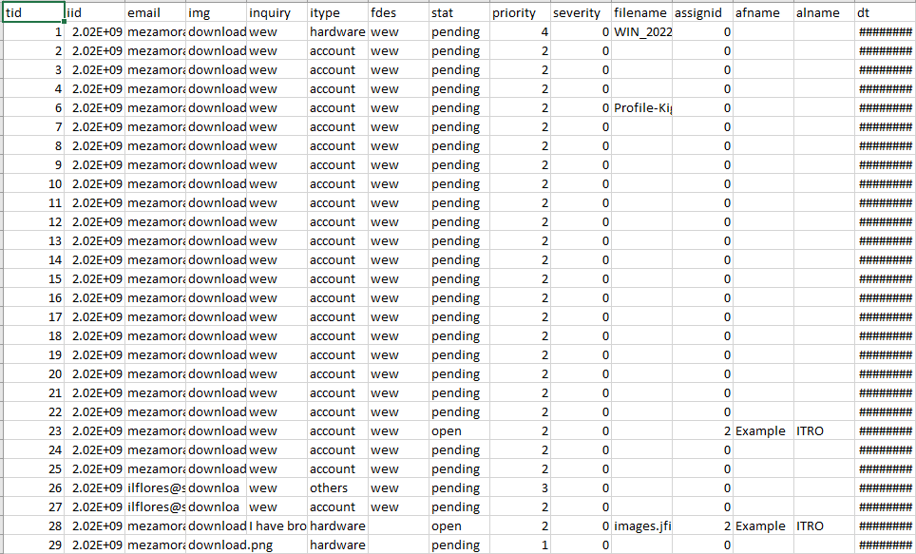

Figure 46: Report Example (Excel)

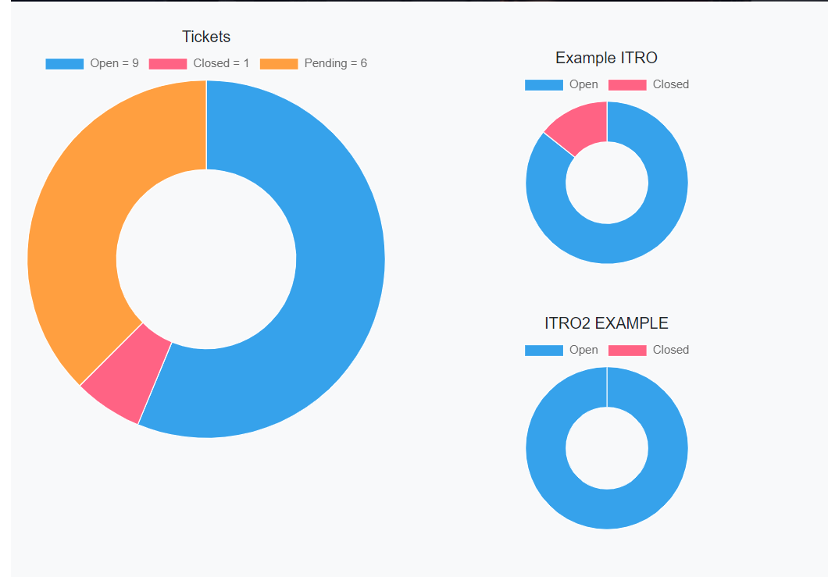

Figure 47: Report Example (Charts)

## Appendix G: External Notification Example

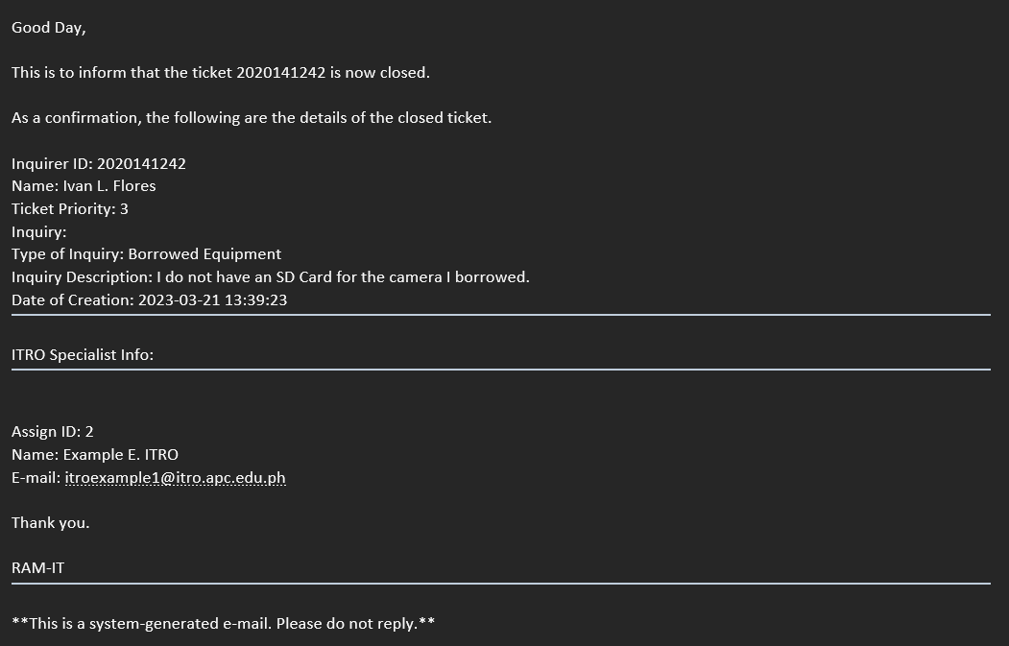

Figure 48: External Notification Example 1

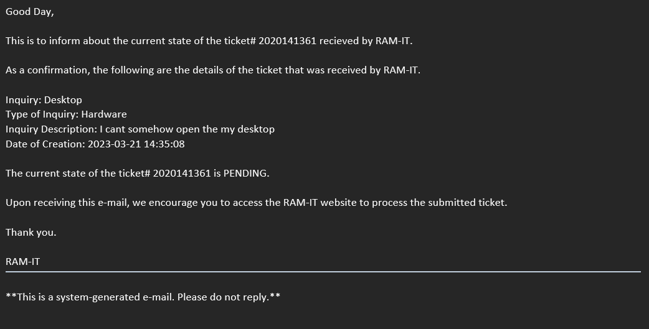

Figure 49: External Notification Example 2

## Appendix H: Priority & Severity Basis

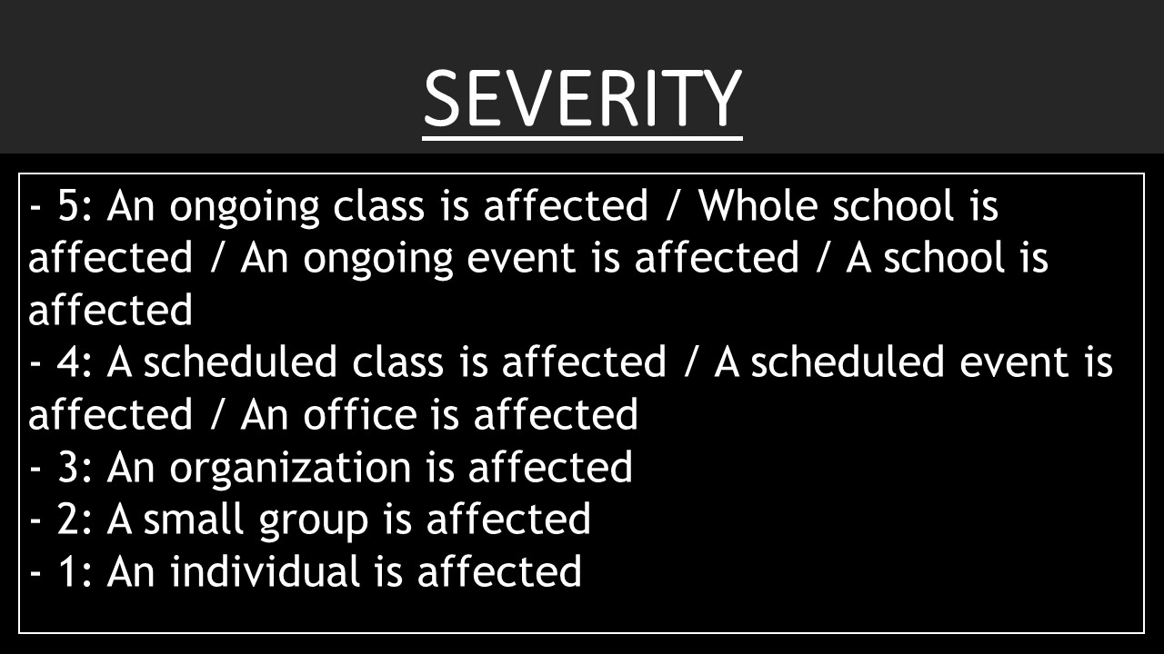

Figure 50: Severity Levels

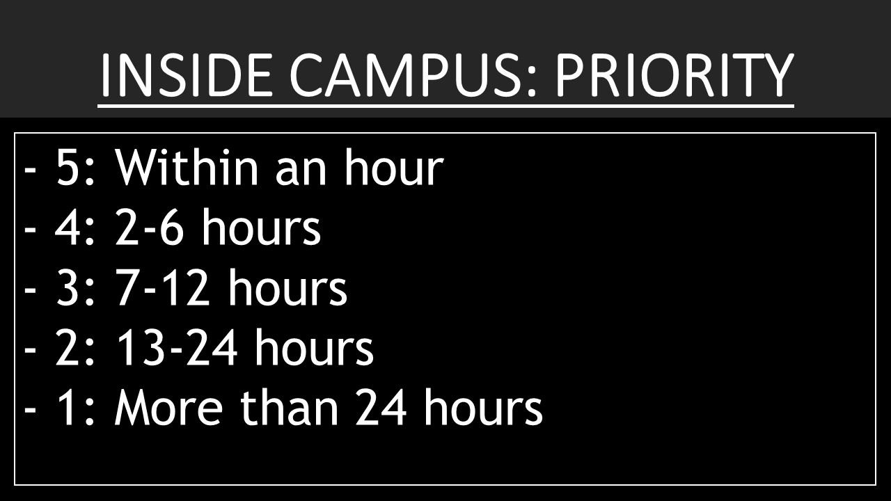

Figure 51: Priority Level: Inside Campus

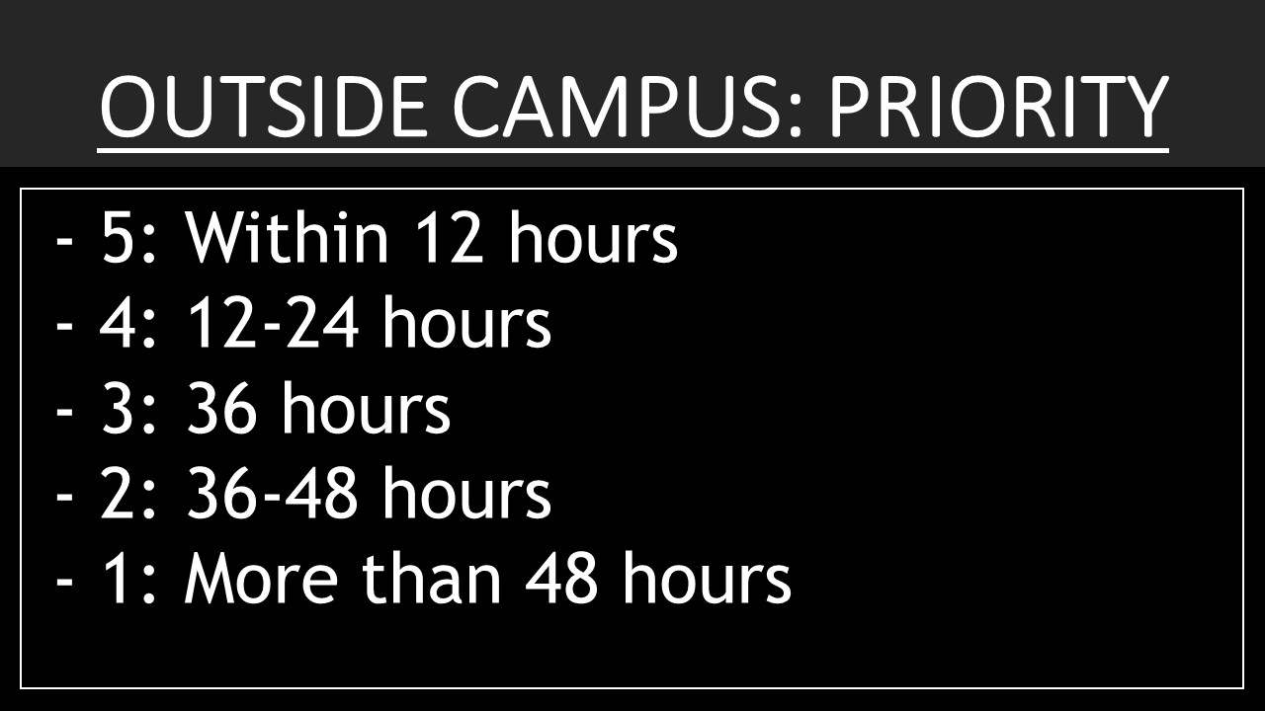

Figure 52: Priority Level: Outside Campus

## Appendix I: Links

[..\[01] Before Midterms\Optimum Five - Gantt Chart V3.pod](../%5b01%5d%20Before%20Midterms/Optimum%20Five%20-%20Gantt%20Chart%20V3.pod)

[..\[01] Before Midterms\Optimum Five - Project Charter V2.docx](../%5b01%5d%20Before%20Midterms/Optimum%20Five%20-%20Project%20Charter%20V2.docx)

[..\[01] Before Midterms\Optimum Five - Software Requirement Specification.docx](../%5b01%5d%20Before%20Midterms/Optimum%20Five%20-%20Software%20Requirement%20Specification.docx)

[..\[01] Before Midterms\Optimum Five - Statement of Work V2.doc](../%5b01%5d%20Before%20Midterms/Optimum%20Five%20-%20Statement%20of%20Work%20V2.doc)

[..\[01] Before Midterms\Optimum Five - Vision & Scope Document V3.docx](../%5b01%5d%20Before%20Midterms/Optimum%20Five%20-%20Vision%20&%20Scope%20Document%20V3.docx)

[..\[01] Before Midterms\Optimum Five - Work Breakdown Structure V2.jpg](../%5b01%5d%20Before%20Midterms/Optimum%20Five%20-%20Work%20Breakdown%20Structure%20V2.jpg)

[..\[02] After Midterms\Optimum Five - Change Management Plan.docx](../%5b02%5d%20After%20Midterms/Optimum%20Five%20-%20Change%20Management%20Plan.docx)

[..\[02] After Midterms\Optimum Five - Quality Plan.docx](../%5b02%5d%20After%20Midterms/Optimum%20Five%20-%20Quality%20Plan.docx)

[..\[02] After Midterms\Optimum Five - Test Cases.xlsx](../%5b02%5d%20After%20Midterms/Optimum%20Five%20-%20Test%20Cases.xlsx)

[..\[02] After Midterms\Optimum Five - User Review.docx](../%5b02%5d%20After%20Midterms/Optimum%20Five%20-%20User%20Review.docx)

## Appendix J: Curriculum Vitae/Resume

1. Jayson Q. Aloya

|  |  |
| --- | --- |
| **Name:** | **Jayson Q. Aloya** |
| **Complete**  **Address:** | #03 Apitong Street, Zone 1, North Signal Village |
| Taguig City |
| **Contact**  **Numbers:** | Landline: 02 956 6563 |
| Mobile number: (+63) 919 333 6763 |
| **Email Address:** | [jqaloya@student.apc.edu.ph](mailto:jqaloya@student.apc.edu.ph)  [business.jaloya@gmail.com](mailto:business.jaloya@gmail.com) |

|  |  |
| --- | --- |
| **Personal**  **Statement** | A student in APC during SHS in which he took STEM with the specialization of Multi Media Arts, and currently in College with the course BSIT with the specialization Mobile and Internet Technology. |
| **Academic Projects** | **“Project RAM Capsule”**   * Is an e-exhibit using a website that takes the email of the interested party, and in 30 years will be sent a code to be able to open the website. * External Communications   **“Little Beginnings: Unlocking Small Business Skills in A Competitive Age”**   * An online event in Facebook where people are taught on what skills to have in starting a small business during the pandemic. * Online Technical Arrangement * Script Writer   **“Ang Pulsong Nabaon sa Ilalim ng Karagatan”**   * A choose your own adventure type of game that is developed in Unity. * Game Designer * Game Developer   **“Takipsilim”**   * Is an application that aims to provide the user an organized way of self-reflecting for them to be able to get to know themselves better and to have a place where they can write their thoughts, feelings, and ideas. * Logo Artist * Project Designer * Project Developer   **“Hamon de Bola”**   * It is a video advertisement about a pig being turned into hamon de bola created by mixing 3D Animation aspects, 2D Animation aspects, and some live action. * Project Manager * Project Organizer * Set Designer * Co-Director   **“Crowdless: Five hashtags for those whom are still self-isolating”**   * It is an entertainment film that serves as a guide for those whom are still self-isolating. * Reelegacy6 Top 10 Finalist * Director * Script Writer * Camera Man * Film Editor   **“RAM-IT”**   * Capstone * Project Leader * Scrum Master * External Communication * Head of Documentation * System Designer   **“The Shadow Speaks”**   * Game * 2D Narrative Platformer * Game Developer |
| **Technical Skills** | * Knowledgeable in Project Management * Knowledgeable in Multi Media Arts * Knowledgeable in Game Programming in Unity & Game Maker Studio 2 * Knowledgeable in using Microsoft Office * Knowledgeable in using Scrum & Agile Methodology * Basic knowledge in: * HTML & CSS * Java * PHP * System Design |
| **Awards & Recognitions** | * Class Representative – (SY 2019-2020) * Reelegacy6 Top 10 Finalist – (SY 2019 – 2020) |
| **Extra-Curricular**  **Activities** | n/a |

1. John Christopher T. Langcauon

|  |  |  |
| --- | --- | --- |
| **Name:** | **JOHN CHRISTOPHER T. LANGCAUON** |  |
| **Complete Address:** | P57 A-15 17th 2nd Street, Villamor |
| Pasay City |
| **Contact Number/s:** | Mobile No.: (0956) 589-3755 |
| **Email Address:** | jtlangcauon@student.apc.edu.ph  [johnchrisme@gmail.com](mailto:johnchrisme@gmail.com) |

|  |  |
| --- | --- |
| **Personal Statement** | Currently a student in Asia Pacific College, striving to learn from superiors in order to be skilled on programming and to become a professional on Information Technology.  Is familiarized with programming and web design, now willing to improve and develop more skills through the course of my education.  Has basic knowledge on Adobe Photoshop and is proficient on MS Office applications like Word and PowerPoint. |
| Education | **Asia Pacific College**, Magallanes, Makati City  **Science, Technology, Engineering, and Mathematics with specialization in Information Technology**  June 2017-present  **Sta. Clara Parish School**, Pasay, Manila  June 2013-March 2017 |
| **Work-Related Courses** | * Practical Research * Empowerment Technology (E-Tech) * Entrepreneurship (Technopreneurship) |
| **Academic Projects** | **“Condemnation”**   * Trailer, April 2018 * Actor   **HearTunes**   * Android application, September 2018 * Lead Designer   **Sunset Over the Moon**   * Visual Novel Game, Dec. 2018 * Lead Designer |
| **Technical Skills** | * Intermediate knowledge and skills in Adobe Photoshop * Basic knowledge and skills in Sony Vegas Pro 11 * Proficient in MS Office: Word, Excel, PowerPoint * Basic knowledge in Web Design |
| **Certifications** | * AMCAT Certification Asia Pacific College, October 2018 * Visual Graphic Design NC III Certificate TESDA, Nov. 2017 |
| **Awards & Recognitions** | * 1st Runner-up, Asia Pacific College Senior High School Vitality Dance Competition, March 2018 * Champion, Bites the Dust Mobile Legends Tournament, Asia Pacific College, December, 2018 * With Honors, SY 2016-2017, Sta. Clara Parish School, March 2017 |
| **Seminars & Trainings Attended** | * “Grit Seminar” in Asia pacific College, December 2017 * “How We Make Games” in Asia Pacific College, August 2017 * Tools in Project Management Workshop in Asia Pacific College, August 2018 |

1. Jan Gabriel Prion

JAN GABRIEL BALCUEVA PRION  
EP HOUSING, TAGUIG CITY 163, 0956 382 3941 jbprion@student.apc.edu.ph

**Professional Summary:**

As an IT student with a passion for technology and problem-solving. I have developed and honed my computer skills through hands-on experience with hardware and software systems, I have gained proficiency in troubleshooting and technical support. Additionally, I possess excellent communication skills and thrive in a work environment. I am seeking a role where I can leverage my technical expertise and collaborate with clients to deliver innovative solutions that drive business value.

**Skills:**

•Interpersonal skills

• Time management

• MS Office

• Technical Writing

• HTML

• CSS

• Content Creation

• Creative Writing

• Attention to detail

**Education:**

Bachelor of Science in Information Technology Undergrad (2020 – Present)  
Asia Pacific College

SHS Graduate in Humanities and Social Science (2018 – 2020)  
Sto Nino Catholic School

JHS Graduate (2014 - 2018)  
Sto Nino Catholic School

1. Marc Julian D. Sajul

|  |  |
| --- | --- |
| **Name:** | **Marc Julian D. Sajul** |
| **Complete**  **Address:** | 60 United Nations, Barangay, Don Bosco, Better Living |
| Parañaque City |
| **Contact**  **Numbers:** | Landline: n/a |
| Mobile no.: (+63) 945 170 1573 |
| **Email Address:** | mdsajul@student.apc.edu.ph  juliansajul@yahoo.com |

|  |  |
| --- | --- |
| **Personal**  **Statement** | A current APC student who carries his passion and the trait of being artistic and creative in his field, a student who is hardworking on doing what he loves, being competent makes him do his best in the field he is in. He seeks hardships to his projects and open gain knowledge and experience that can contribute to his future projects. Has an ability to initiate and provide leadership to make team collab and to work effectively and efficiently. |
| **Academic Projects** | **“ASOcia”**   * A mating website for Dogs * Developer   **“Coding Park”**   * Game * 2D Platformer * UI Designer   **“Guide to Mental Health: COVID-19”**   * Research Paper * Project Conceptor * Project Contributor * Compilation of students’ works   **“Inevitable”**   * Chapter Book * Visual Editor * Compilation of students’ works   **“Legend of Ziusudra”**   * Game High Concept Document * Author * Story Bible Document * Storyboard Materials Document * Benchmark Document   **“Obsession”**   * Short Film * Supporting Actor * Awarded Best Short Film   **“RAM-IT”**   * Capstone * Project Owner * Project Conceptor * Project Contributor * UI/UX Lead Designer * UI/UX Programmer   **“Swiftblade AD”**   * Gaming Mouse Advetisement * Actor * Resource Management and Design   **“The Shadow Speaks”**   * Game * 2D Platformer * UI Designer   **“XO Kitchen's Ordering Services”**   * Project Conceptor * UI/UX Designer * Compilation of students’ works |
| **Technical Skills** | * Knowledgeable in Video Editing and Production * Knowledgeable in Graphic Design * Knowledgeable in Game Programming, Design and UI Design * Knowledgeable in using Microsoft Office * Has knowledge in: * Android Studio * Visual Studio Code * HTML * Java * Has a basic knowledge in: * Python * Eclipse * Arduino * Basic knowledge at Database management and SQL |
| **Awards & Recognitions** | * Loyalty Award – (SY 2013 – 2018) * Best in Thesis – (SY 2017 – 2018) * Best in Poster Making – (SY 2012 – 2016) * Best in Slogan Making – (SY 2013 – 2014) * Loyalty Award – (AY 2019 – 2020) * With Honors – (AY 2021 – 2022) |
| **Extra-Curricular**  **Activities** | n/a |

1. Marc E. Zamora

|  |  |  |
| --- | --- | --- |
| **Name:** | **MARC E. ZAMORA** |  |
| **Complete Address:** | 1269 Saint Peter St. Brgy. 184 Malibay |
| Pasay City |
| **Contact Number/s:** | Landline: N/a |
| Mobile No.: 09260731991 |
| **Email Address:** | [mezamora@student.apc.edu.ph](mailto:mezamora@student.apc.edu.ph)  marczamora143@gmail.com |



|  |  |
| --- | --- |
| **Personal Statement** | Currently studying in Asia Pacific College who can offer a wide range of knowledge in programming I am a student that can help to improve requirements of an application’s services and features. I am Compatible to an environment who accepts failures and criticisms,  I am a Hardworking student with self-discipline, time management and has a sense of work ethics I have knowledge in Java, but I am eager to learn more knowledge in Visual Studio, C++, Java, Python, and many more |
| Education | **Asia Pacific College**, Magallanes, Makati City  **STEM- I.T.**  **(Information Technology)**  June 2018-present |
| **Academic Projects** | Sta Aisa   * Visual Novel, August 2019 * Video Game * Co-Lead Application Developer * Co-Group Project Manager   MunchBook   * Recipe application, September 2019 * Cooking application * Co-Lead Application Developer * Co-Group Project Manager     Coding Park   * Game, 2021 * 2d platforming puzzle game * Head Application Developer * Head Project Manager |
| **Technical Skills** | * Proficient in MS Office: Word, Excel, PowerPoint * Basic knowledge in Photography and Video editing * Intermediate knowledge and skills in Java programming * Proficient in Eclipse, Notepad++, Android Studio, and Unity * Proficient in PHP, JavaScript and Java (still learning C# and C++) |
| **Awards & Recognitions** | * Participant, Ins and Outs of Microsoft Technologies  Asia Pacific College, May 2019 |
| **Seminars & Trainings Attended** | * Inspired Conversation with Filipina CEO Circle by Asia Pacific College, July 2019 * Ins and Outs of Microsoft Technologies by APC Microsoft Community  Asia Pacific College, May 2019 |
| **Extra-Curricular Activities** | * Teatro Phileo, Member, SY 2018-2019 |

## Appendix K: Team Meetings

**MSYADD1 Meetings**

**Minutes of the Meeting - 8/28/22 Sunday**



Figure 53: Minutes of the Meeting - 8/28/22 Sunday

Opening:

An online meeting of the Optimum Five group was called to order from 8:00 PM – 10:23 PM on August 28, 2022, via Microsoft Teams.

Present

Marc Zamora

Jayson Aloya

John Christopher Langcauon

Marc Julian Sajul

Jan Gabriel Prion

Absent

None

Model-View and Controller infographic

All the documents and PowerPoints that were presented and made by Jayson Aloya

Agenda:

* MVC alterations
* Discussion and changes
* Previous Comment Matrix
* Discussion
* Progress Report – Week 2

Adjournment:

The meeting adjourned at 10:23 PM by Jayson Aloya, and reconvened on August 28, 2022 (8:00 PM) via online using Microsoft Teams.

**Minutes of the Meeting - 8/29/22 Monday**



Figure 54: Minutes of the Meeting - 8/29/22 Monday

Opening:

An online meeting of the Optimum Five group was called to order from 8:00 PM – 10:40 PM on August 29, 2022, via Microsoft Teams.

Present

Marc Zamora

Jayson Aloya

John Christopher Langcauon

Marc Julian Sajul

Jan Gabriel Prion

Absent

 None

MCV alteration and updates to the diagrams

All the documents and PowerPoints that were presented and made by Jayson Aloya

Agenda:

* MCV alteration
* Discussion about changes
* MVC alterations
* Discussion and changes
* Even Table
* Discussion

Adjournment:

The meeting adjourned at 10:40 PM by Jayson Aloya, and has reconvened on August 29, 2022 (8:00 PM) via online using of Microsoft Teams.

**Minutes of the Meeting - 8/31/22 Wednesday**



Figure 55: Minutes of the Meeting - 8/31/22 Wednesday

Opening:

An online meeting of the Optimum Five group was called to order from 9:00 PM – 10:12 PM on August 31, 2022, via Microsoft Teams.

Present

Marc Zamora

Jayson Aloya

John Christopher Langcauon

Marc Julian Sajul

Jan Gabriel Prion

Absent

None

MCV alteration and updates to the diagrams

All the documents and PowerPoints that were presented and made by Jayson Aloya

Agenda:

* MVC alterations
* Discussion and changes
* Even Table
* Discussion and changes

Adjournment:

The meeting adjourned at 10:12 AM by Jayson Aloya, and has reconvened on August 31, 2022 (9:00PM) via online using Microsoft Teams.

**Minutes of the Meeting - 9/7/22 Wednesday**

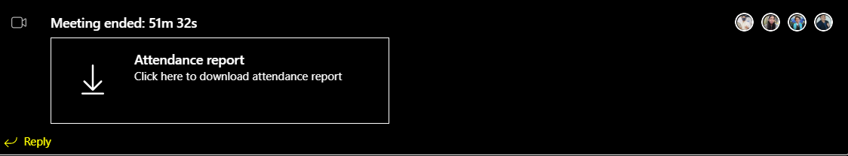

Figure 56: Minutes of the Meeting - 9/7/22 Wednesday

Opening:

An online meeting of the Optimum Five group was called to order from 9:00 PM – 9:51 PM on September 7, 2022, via Microsoft Teams.

Present

Marc Zamora

Jayson Aloya

John Christopher Langcauon

Marc Julian Sajul

Absent

Jan Gabriel Prion

Diagrams and paper prep presentation

All the documents and PowerPoints that were presented and made by Jayson Aloya

Agenda:

* Activity Diagram
* Discussion
* Object Diagram
* Discussion
* Sprint 2
* Midterm paper
* Comment Matrix

Adjournment:

The meeting adjourned at 9:51 AM by Jayson Aloya, and has reconvened on September 7, 2022 (9:00 PM) via online using Microsoft Teams.

**Minutes of the Meeting - 9/15/22 Wednesday**

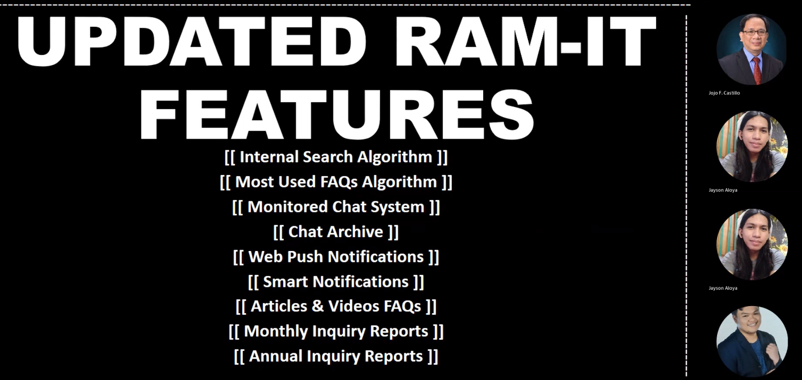

Figure 57: Minutes of the Meeting - 9/15/22 Wednesday

Opening:

An online meeting of the Optimum Five group was called to order from 9:30 AM – 11:42 AM on September 15, 2022, via Microsoft Teams.

Present

Marc Zamora

Jayson Aloya

John Christopher Langcauon

Marc Julian Sajul

Jan Gabriel Prion

Absent

None

RAM-IT

All the documents and PowerPoints that were presented and made by Jayson Aloya

Agenda:

* Inform the client
* Updates
* Discussion about changes

Adjournment:

The meeting adjourned at 11:42 AM by Jayson Aloya, and has reconvened on September 15, 2022 (9:30 AM) via online using Microsoft Teams.

**Minutes of the Meeting - 9/20/22 Tuesday**

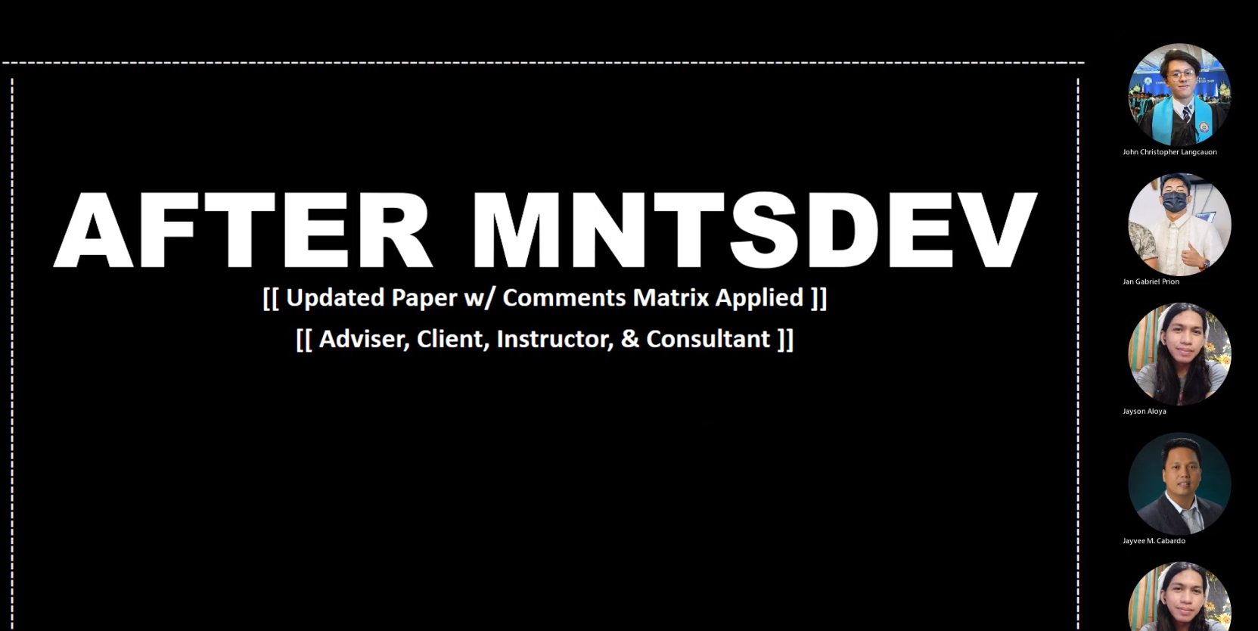

Figure 58: Minutes of the Meeting - 9/20/22 Tuesday

Opening:

An online meeting of the Optimum Five group was called to order from 11:30 AM – 12:17 PM on September 20, 2022, via Microsoft Teams.

Present

Jayson Aloya

John Christopher Langcauon

Marc Julian Sajul

Jan Gabriel Prion

Absent

Marc Zamora

RAM-IT

All the documents and PowerPoints that were presented and made by Jayson Aloya

Agenda:

* Present paper
* Updates
* Discussion about changes

• Seek consultation with the consultant

Adjournment:

The meeting adjourned at 12:17 AM by Jayson Aloya, and has reconvened on September 20, 2022 (11:30 AM) via online using Microsoft Teams.

**Minutes of the Meeting - 9/21/22 Thursday**

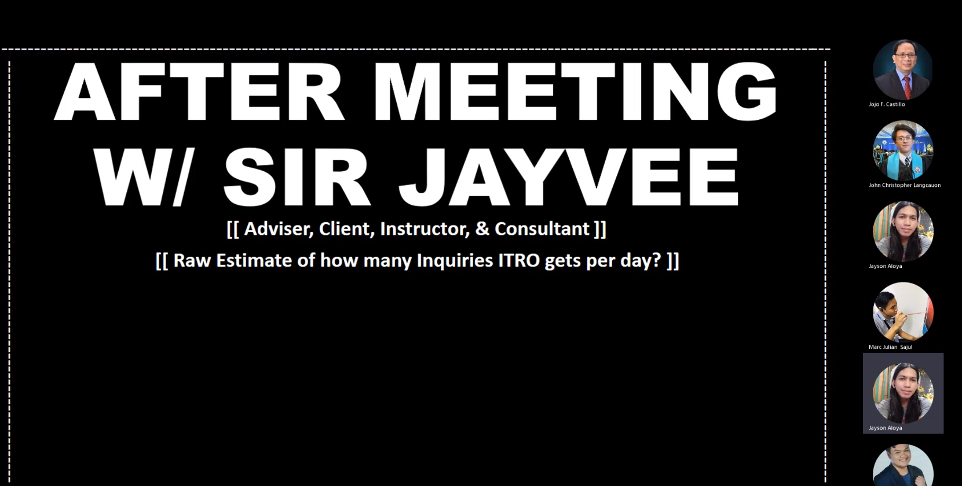

Figure 59: Minutes of the Meeting - 9/21/22 Thursday

Opening:

An online meeting of the Optimum Five group was called to order from 9:30 AM – 11:42 AM on September 21, 2022, in Microsoft Teams.

Present

Marc Zamora

Jayson Aloya

John Christopher Langcauon

Marc Julian Sajul

Absent

Jan Gabriel Prion

RAM-IT AI & Ticketing System

All the documents and PowerPoints that were presented and made by Jayson Aloya

Agenda:

* Inform the client
* Updates
* Discussion about changes
* Question the statistics of inquiries in ITRO

Adjournment:

The meeting adjourned at 11:42 AM by Jayson Aloya, and has reconvened on September 21, 2022 (9:30 AM) via online using Microsoft Teams.

**Minutes of the Meeting - 9/23/22 Friday**

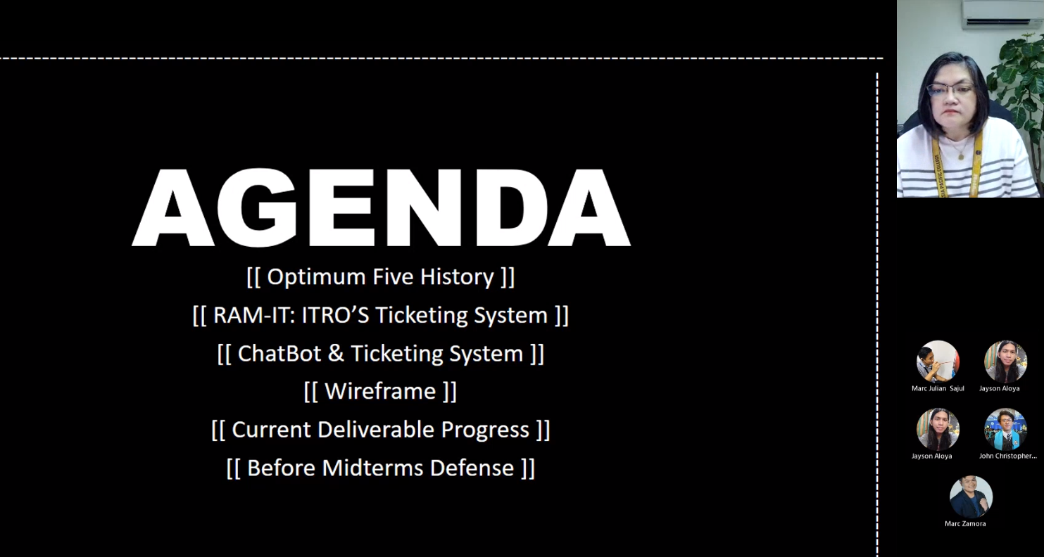

Figure 60: Minutes of the Meeting - 9/23/22 Friday

Opening:

An online meeting of the Optimum Five group was called to order from 9:30 AM – 10:42 AM on September 23, 2022, via Microsoft Teams.

Present

Marc Zamora

Jayson Aloya

John Christopher Langcauon

Marc Julian Sajul

Jan Gabriel Prion

Absent

None

RAM-IT AI & Ticketing System

All the documents and PowerPoints that were presented and made by Jayson Aloya

Agenda:

* Inform the client
* Updates
  + - Discussion about changes
* Question the statistics of inquiries in ITRO

Adjournment:

The meeting adjourned at 10:42 AM by Jayson Aloya, and has reconvened on September 23, 2022 (9:30 AM) via online using Microsoft Teams.

**Minutes of the Meeting - 9/25/22 Sunday**



Figure 61: Minutes of the Meeting - 9/25/22 Sunday

Opening:

An online meeting of the Optimum Five group was called to order from 9:00 PM – 6:56 PM on September 25, 2022, in Microsoft Teams.

Present

Marc Zamora

Jayson Aloya

John Christopher Langcauon

Marc Julian Sajul

Jan Gabriel Prion

Absent

None

Change of Proposal

All the documents and PowerPoints that were presented and made by Jayson Aloya

Agenda:

* Project Paper
* Discussion about changes
* Diagrams
* Discussion
* Schedule
* Discussion
* QNA

Adjournment:

The meeting adjourned at 6:56 PM by Jayson Aloya, and has reconvened on September 25, 2022 (9:00 PM) via online using Microsoft Teams.

**Minutes of the Meeting - 9/27/22 Tuesday**

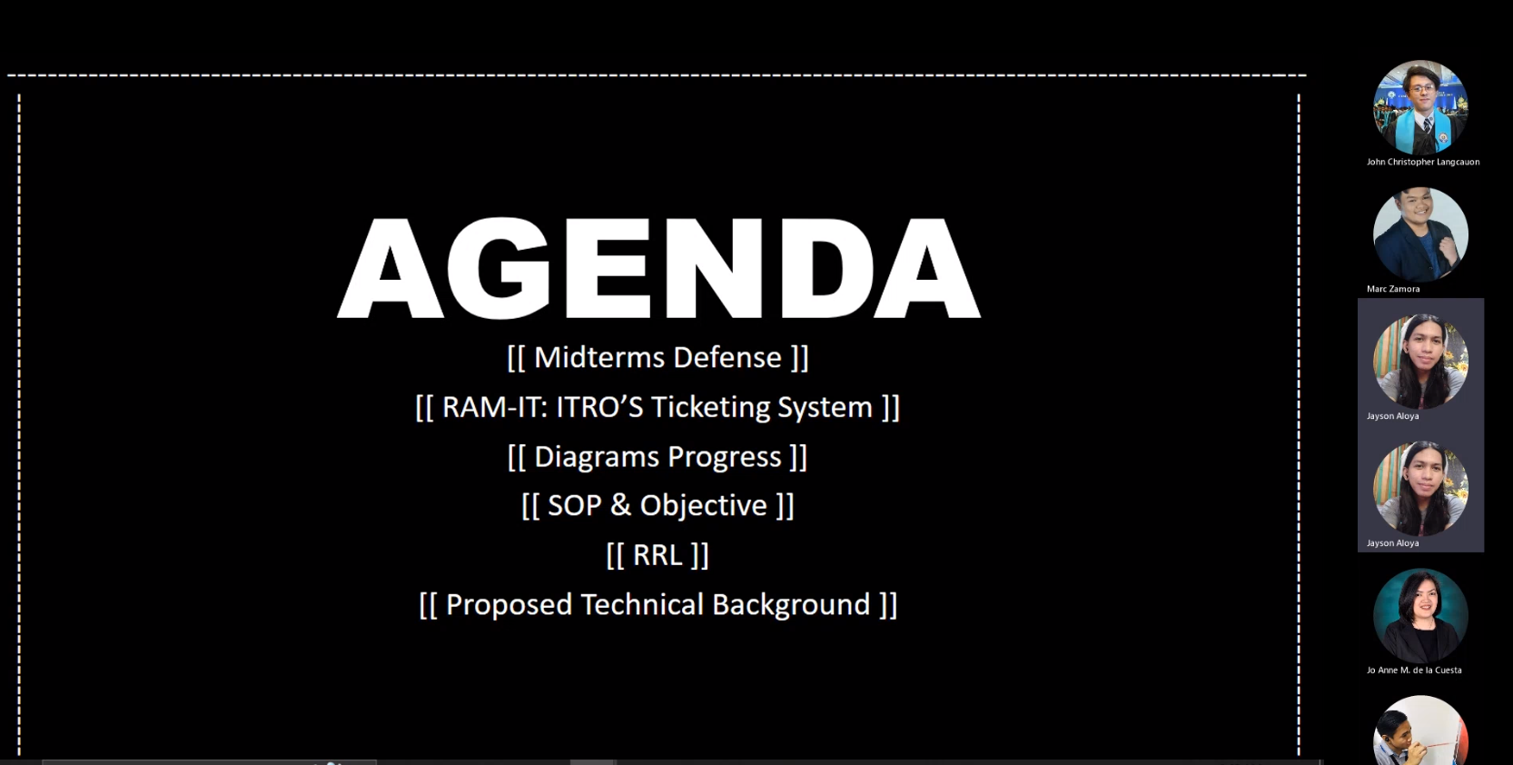

Figure 62: Minutes of the Meeting - 9/27/22 Tuesday

Opening:

An online meeting of the Optimum Five group was called to order from 9:30 AM – 10:42 AM on September 27, 2022, via Microsoft Teams.

Present

Marc Zamora

Jayson Aloya

John Christopher Langcauon

Marc Julian Sajul

Jan Gabriel Prion

Absent

None

RAM-IT AI & Ticketing System

All the documents and PowerPoints that were presented and made by Jayson Aloya

Agenda:

* Inform the client
* Updates
* Discussion about changes

Adjournment:

The meeting adjourned at 10:42 AM by Jayson Aloya, on September 27, 2022 (9:30 AM) via online using Microsoft Teams.

**Minutes of the Meeting - 9/29/22 Thursday**

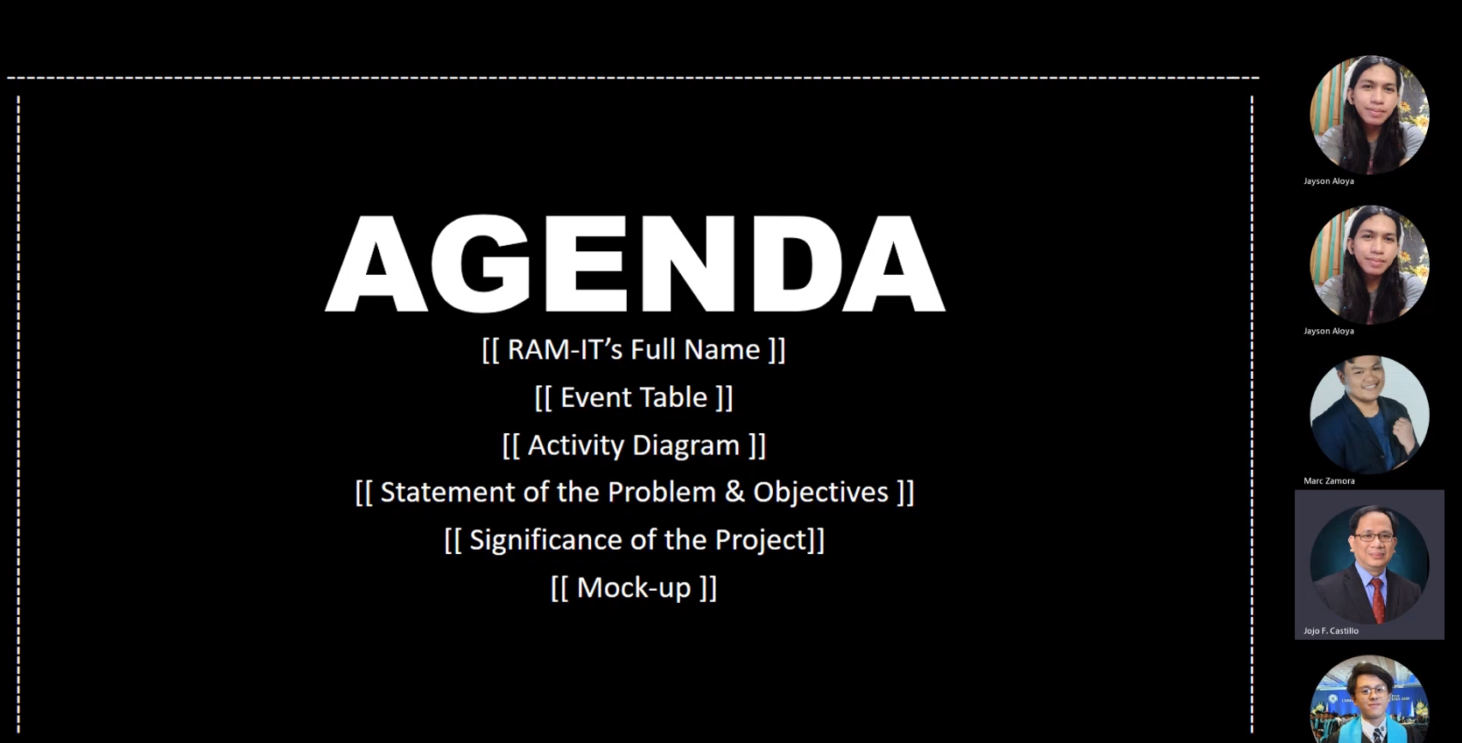

Figure 63: Minutes of the Meeting - 9/29/22 Thursday

Opening:

An online meeting of the Optimum Five group was called to order from 9:30 AM – 10:42 AM on September 29, 2022, via Microsoft Teams.

Present

Marc Zamora

Jayson Aloya

John Christopher Langcauon

Marc Julian Sajul

Absent

Jan Gabriel Prion

RAM-IT AI & Ticketing System

All the documents and PowerPoints that were presented and made by Jayson Aloya

Agenda:

* Inform the client
* Updates
* Discussion about changes
* Question the statistics of inquiries in ITRO

Adjournment:

The meeting adjourned at 10:42 AM by Jayson Aloya, and has reconvened on September 29, 2022 (9:30 AM) via online using Microsoft Teams.

**Minutes of the Meeting - 9/30/22 Friday**



Figure 64: Minutes of the Meeting - 9/30/22 Friday

Opening:

An online meeting of the Optimum Five group was called to order from 10:00 PM – 3:04 AM on September 30, 2022, via Microsoft Teams.

Present

Marc Zamora

Jayson Aloya

John Christopher Langcauon

Marc Julian Sajul

Absent

Jan Gabriel Prion

RAM-IT AI & Ticketing System

All the documents and PowerPoints that were presented and made by Jayson Aloya

Agenda:

* Updates
* Discussion about changes

Adjournment:

The meeting adjourned at 3:03 AM by Jayson Aloya, and has reconvened on September 30, 2022 (10:00 PM) online using Microsoft Teams.

**Minutes of the Meeting - 10/1/22 Saturday**

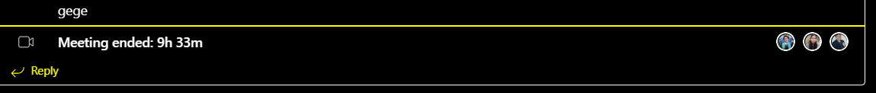

Figure 65: Minutes of the Meeting - 10/1/22 Saturday

Opening:

An online meeting of the Optimum Five group was called to order from 10:00 AM – 6:00 PM on October 1, 2022, via Microsoft Teams.

Present

Marc Zamora

Jayson Aloya

John Christopher Langcauon

Marc Julian Sajul

Absent

Jan Gabriel Prion

RAM-IT AI & Ticketing System

All the documents and PowerPoints that were presented and made by Jayson Aloya

Agenda:

* Updates
* Discussion about changes

Adjournment:

The meeting adjourned at 6:33 PM by Jayson Aloya, and has reconvened on October 1, 2022 (10:00 AM) online using Microsoft Teams.

**Minutes of the Meeting - 10/1/22 Saturday**

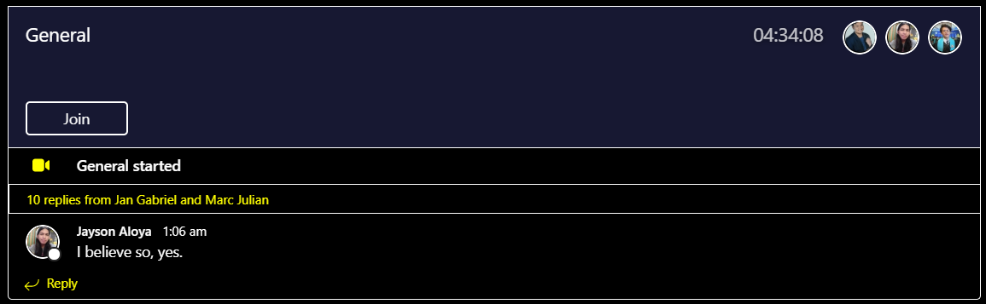

Figure 66: Minutes of the Meeting - 10/1/22 Saturday

Opening:

An online meeting of the Optimum Five group was called to order from 11:00 PM – 3:34 PM on October 1, 2022, via Microsoft Teams.

Present

Marc Zamora

Jayson Aloya

John Christopher Langcauon

Marc Julian Sajul

Absent

Jan Gabriel Prion

RAM-IT AI & Ticketing System

All the documents and PowerPoints that were presented and made by Jayson Aloya

Agenda:

* Updates
* Discussion about changes

Adjournment:

The meeting adjourned at 3:34 AM by Jayson Aloya, and has reconvened on October 1, 2022 (11:00 PM) via online using Microsoft Teams.

**Minutes of the Meeting - 10/20/22 Tuesday**

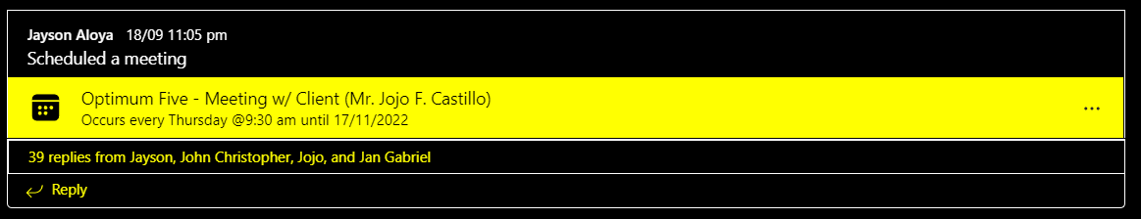

Figure 67: Minutes of the Meeting - 10/20/22 Tuesday

Opening:

An online meeting of the Optimum Five group was called to order from 9:00 AM – 10:00 AM on October 15, 2022, via Microsoft Teams.

Present

Marc Zamora

Jayson Aloya

John Christopher Langcauon

Marc Julian Sajul

Jan Gabriel Prion

Absent

RAM-IT AI & Ticketing System

All the documents and PowerPoints that were presented and made by Jayson Aloya

The prototype was presented by Marc E. Zamora

Agenda:

* Updates
* Discussion about the prototype

Adjournment:

The meeting adjourned at 10 AM by Jayson Aloya, and has reconvened on October 27, 2022 (11:00 PM) via online using Microsoft Teams.

**Minutes of the Meeting - 10/20/22 Thursday**



Figure 68: Minutes of the Meeting - 10/20/22 Thursday

Opening:

An online meeting of the Optimum Five group was called to order from 9:30 AM – 9:53 AM on October 10, 2022, via Microsoft Teams.

Present

Marc Zamora

Jayson Aloya

John Christopher Langcauon

Marc Julian Sajul

Jan Gabriel Prion

Absent

RAM-IT AI & Ticketing System

All the documents and PowerPoints that were presented and made by Jayson Aloya

The prototype was presented by Marc E. Zamora

Agenda:

* Updates
* Discussion about the prototype

Adjournment:

The meeting adjourned at 10 AM by Jayson Aloya, and has reconvened on October 27, 2022 (11:00 PM) via online using Microsoft Teams.

**Minutes of the Meeting - 11/4-6/22 Friday - Sunday**

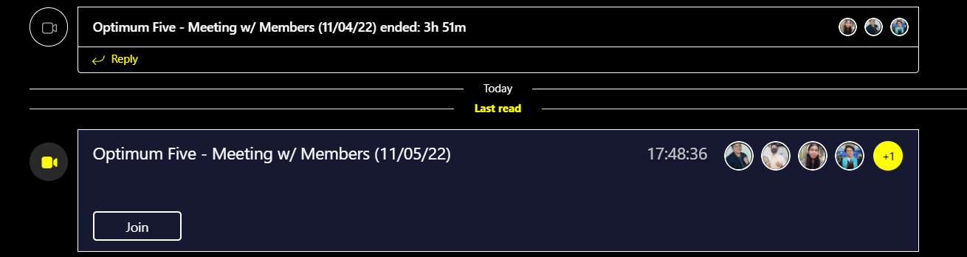

Figure 69: Minutes of the Meeting - 11/4-6/22 Friday - Sunday

Opening:

An online meeting of the Optimum Five group was called to order from 11:00 PM – 3:34 AM on November 4, 2022, via Microsoft Teams.

Present

Marc Zamora

Jayson Aloya

John Christopher Langcauon

Marc Julian Sajul

Jan Gabriel Prion

Absent

Jan Gabriel Prion (Friday)

Marc Julian Sajul (Friday)

RAM-IT AI & Ticketing System

All the documents and PowerPoints that were presented and made by Jayson Aloya

Agenda:

* Updates
* Discussion about changes in the prototype and paper

Adjournment:

The meeting adjourned at 6 PM by Jayson Aloya, and has reconvened on November 7, 2022 (11:00 PM) via online using Microsoft Teams.

**MCSPROJ Meetings**

**Minutes of the Meeting – 11/29/2022**

Opening:

An online meeting of the Optimum Five group with Sir Jojo Castillo (Client) was called to order from 9:30 PM – 11:15 PM on November 29, 2022, via Microsoft Teams.

Present

Jayson Aloya

John Christopher Langcauon

Marc Zamora

Marc Julian Sajul

Jan Gabriel Prion

Absent

None

Approval of Documentation

Approval of Documentation made by John Christopher Langcauon and seconded by Jayson Aloya

Agenda

* Discussion regarding the following:
  + Delegation of Roles and Responsibilities of team members
    - Marc Julian Sajul
      * Front-End Code
    - Marc Zamora
      * Back-End Code
    - Jayson Aloya
      * Visuals
      * Diagrams
      * Comments Matrix
    - John Christopher Langcauon
      * Documentation
      * Visuals
      * Gathering of Data
    - Jan Gabriel Prion
      * Gathering of Data
  + Discussion about Gantt Chart
  + Learning on how to use fork for GitHub

Adjournment:

The meeting adjourned at 11:15 PM by Jayson Aloya, and will reconvene later and has been advised to its members and will be done online using Microsoft Teams.

**Minutes of the Meeting – 1/9/2023**

Opening:

An online meeting of the Optimum Five group with Sir Jojo Castillo (Client) was called to order from 2:00 PM – 3:00 PM on November 29, 2022, via Microsoft Teams.

Present

Jayson Aloya

John Christopher Langcauon

Marc Zamora

Marc Julian Sajul

Jan Gabriel Prion

Absent

None

Approval of Documentation

Approval of Documentation made by John Christopher Langcauon and seconded by Jayson Aloya

Agenda

* Showcase of the project prototype
  + Discussion on collaborating when developing the chat system

Adjournment:

The meeting adjourned at 3:00 PM by Jayson Aloya, and will reconvene later and has been advised to its members and will be done online using Microsoft Teams.

**Minutes of the Meeting – 1/12/2023**

Opening:

An online meeting of the Optimum Five group with Ms. Jo Anne De La Cuesta (Project Advisor) was called to order from 2:30 PM – 3:30 PM on January 12, 2023, via Microsoft Teams.

Present

Jayson Aloya

John Christopher Langcauon

Marc Zamora

Marc Julian Sajul

Absent

Jan Gabriel Prion

Approval of Documentation

Approval of Documentation made by John Christopher Langcauon and seconded by Jayson Aloya

Agenda

* Showcase of the following:
  + Updates and improvements of the project prototype
  + Project team’s roles and timetable for deliverables
* Discussion about Contingency Plan

Adjournment:

The meeting adjourned in 11:15 PM by Jayson Aloya, and will reconvene later and has been advised to its members and will be done online using Microsoft Teams.

**Minutes of the Meeting – 1/16/2023**

Opening:

An online meeting of the Optimum Five group with Sir Jojo Castillo (Client) was called to order from 2:00 PM – 3:00 PM on November 29, 2022, via Microsoft Teams.

Present

Jayson Aloya

John Christopher Langcauon

Marc Julian Sajul

Absent

Marc Zamora

Jan Gabriel Prion

Approval of Documentation

Approval of Documentation made by John Christopher Langcauon and seconded by Jayson Aloya

Agenda

* Showcase of the project prototype
* Discussion about the following:
  + Contingency Plan
  + Reports
  + Notifications

Adjournment:

The meeting adjourned in 2:27 PM by Jayson Aloya, and will reconvene later and has been advised to its members and will be done online using Microsoft Teams.

**Minutes of the Meeting – 1/17/2023**

Opening:

An online meeting of the Optimum Five group with Sir Jayvee M. Cabardo was called to order from 9:30 AM – 10:30 AM on January 17, 2023, via Microsoft Teams.

Present

Jayson Aloya

John Christopher Langcauon

Marc Zamora

Marc Julian Sajul

Absent

Jan Gabriel Prion

Approval of Documentation

Approval of Documentation made by John Christopher Langcauon and seconded by Jayson Aloya

Agenda

* Showcase of the following:
  + Updates and improvements of the project prototype
* Discussion about the following:
  + Current contingency plan is
  + Reports system
  + Notification system
    - The system needs basis to justify the ticket count until the ITRO receives a notification

Adjournment:

The meeting adjourned in 9:58 AM by Jayson Aloya, and will reconvene later and has been advised to its members and will be done online using Microsoft Teams.

**Minutes of the Meeting – 2/15/2023**

Opening:

An online meeting of the Optimum Five group with Ms. Jo Anne de la Cuesta (Adviser) was called to order from 9:45 AM – 10:45 PM on February 14, 2023, via Microsoft Teams.

Present

Jayson Aloya

Marc Julian Sajul

Marc Zamora

Absent

Jan Gabriel Prion

John Christopher Langcauon

Approval of Documentation

Approval of Documentation made by John Christopher Langcauon and seconded by Jayson Aloya

Agenda

* Discussion about the following:
  + Responsibility Delegations
  + Midterms comments (Improvement Matrix)
  + Timetable
  + Prototype

Adjournment:

The meeting adjourned in 10:45 am by Jayson Aloya, and will reconvene later and has been advised to its members and will be done online using Microsoft Teams.

**Minutes of the Meeting – 2/17/2023**

Opening:

An online meeting of the Optimum Five group with Ms. Jo Anne de la Cuesta (Adviser) was called to order from 3:30 PM – 4:30 PM on February 17,2023, via Microsoft Teams.

Present

Jayson Aloya

Marc Julian Sajul

Marc Zamora

John Christopher Langcauon

Absent

Jan Gabriel Prion

Approval of Documentation

Approval of Documentation made by John Christopher Langcauon and seconded by Jayson Aloya

Agenda

* Prototype showcase, the following are discussed:
  + Updates on the integration of features written on the paper
    - Viewer Perspective and Specialist Perspective
    - Chat Window
    - Chatbot
    - Downloading of Report

Adjournment:

The meeting adjourned in 4:30 pm by Jayson Aloya, and will reconvene later and has been advised to its members and will be done online using Microsoft Teams.

**Minutes of the Meeting – 2/23/2023**

Opening:

An online meeting of the Optimum Five group with Sir Jojo Castillo (Client) was called to order from 1:30 PM – 2:30 PM on February 23, 2023, via Microsoft Teams.

Present

Jayson Aloya

Marc Zamora

Jan Gabriel Prion

Absent

John Christopher Langcauon

Marc Julian Sajul

Approval of Documentation

Approval of Documentation made by John Christopher Langcauon and seconded by Jayson Aloya

Agenda

* Prototype showcase, the following are discussed:
  + Prototype updates since last meeting
  + Integration of Notifications
  + Severity and Priority

The meeting adjourned in 2:30 pm by Jayson Aloya, and will reconvene later and has been advised to its members and will be done online using Microsoft Teams.